Week 1:

CIA and CIA Examples with Online bank

When someone’s network is secure,

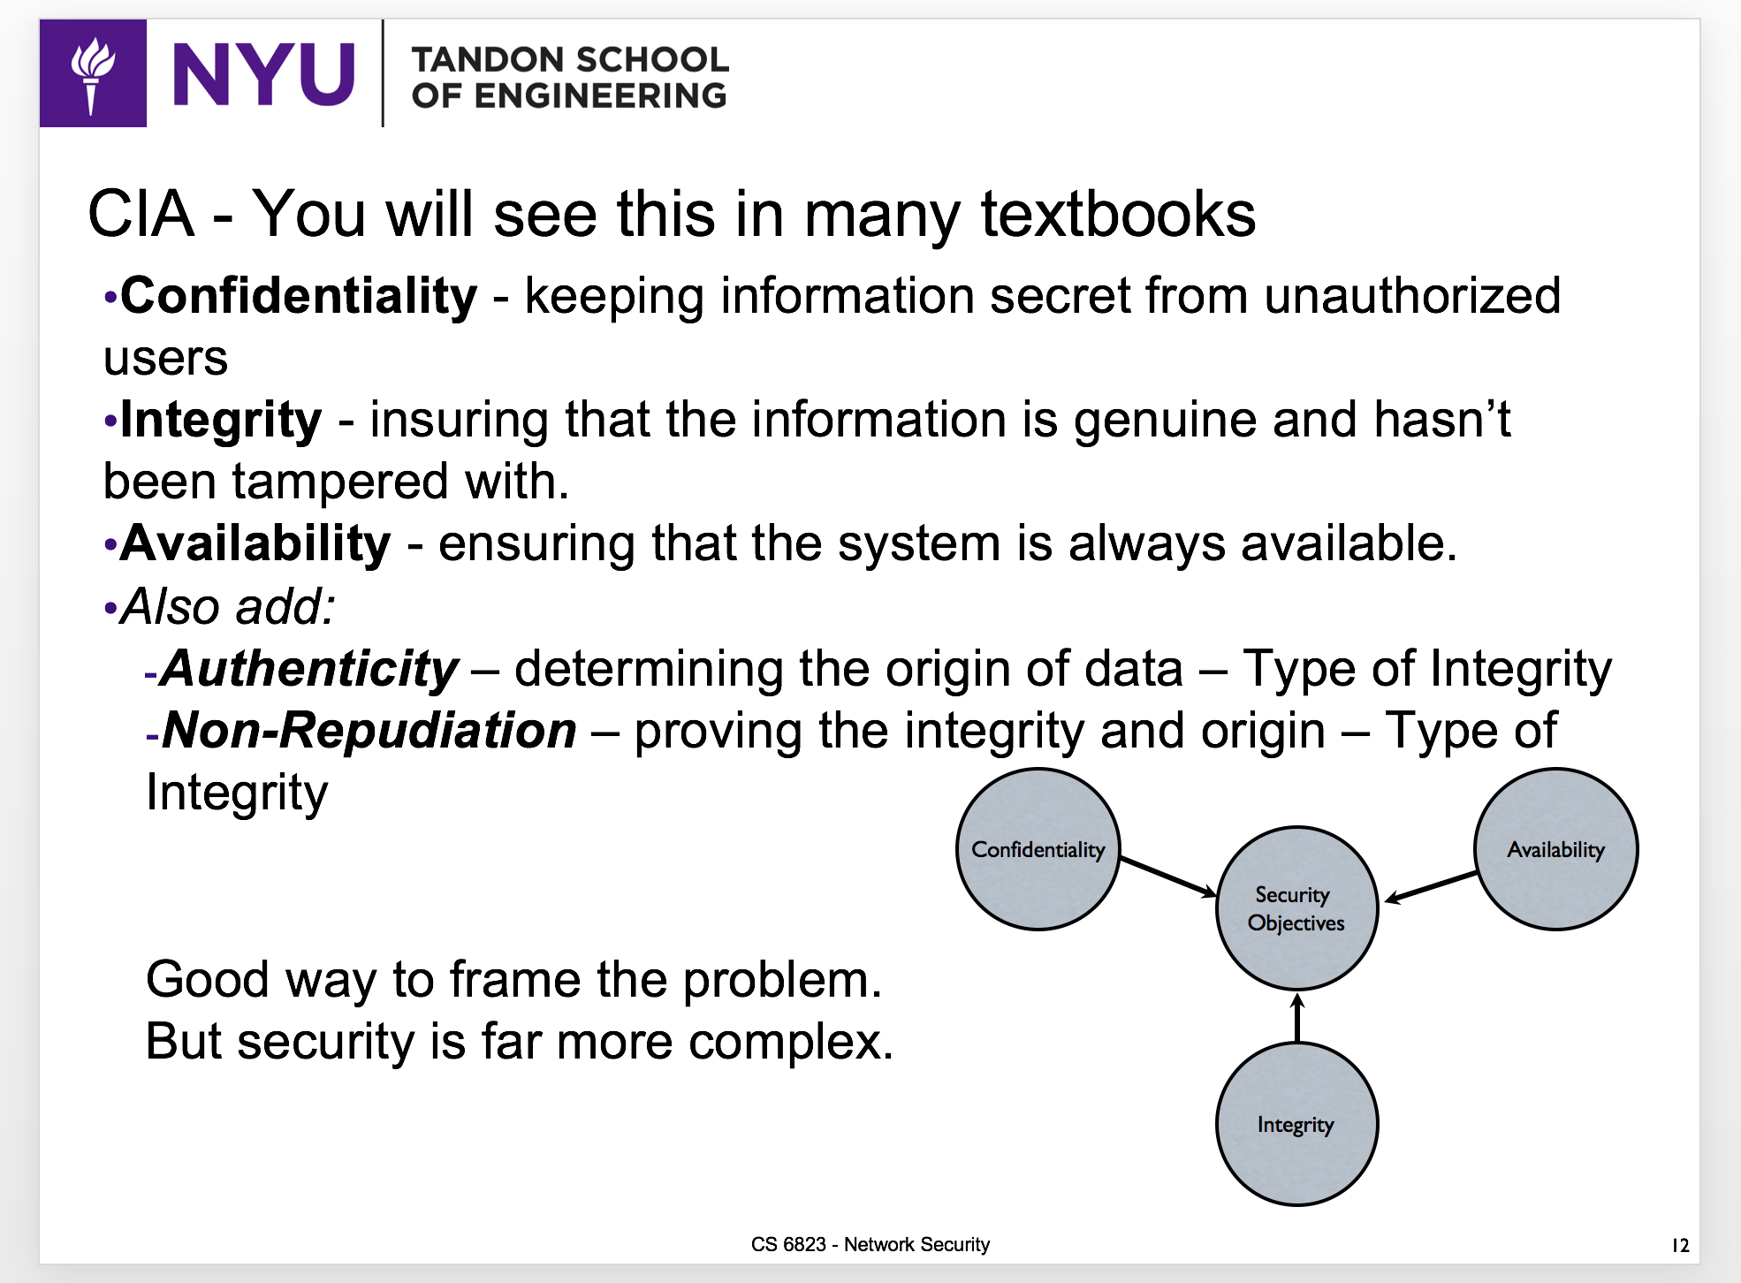

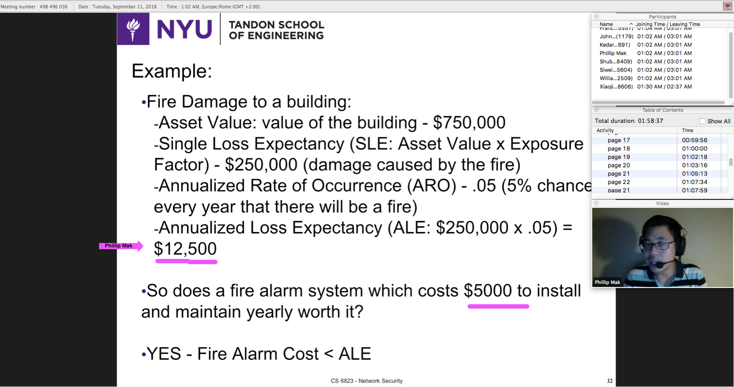

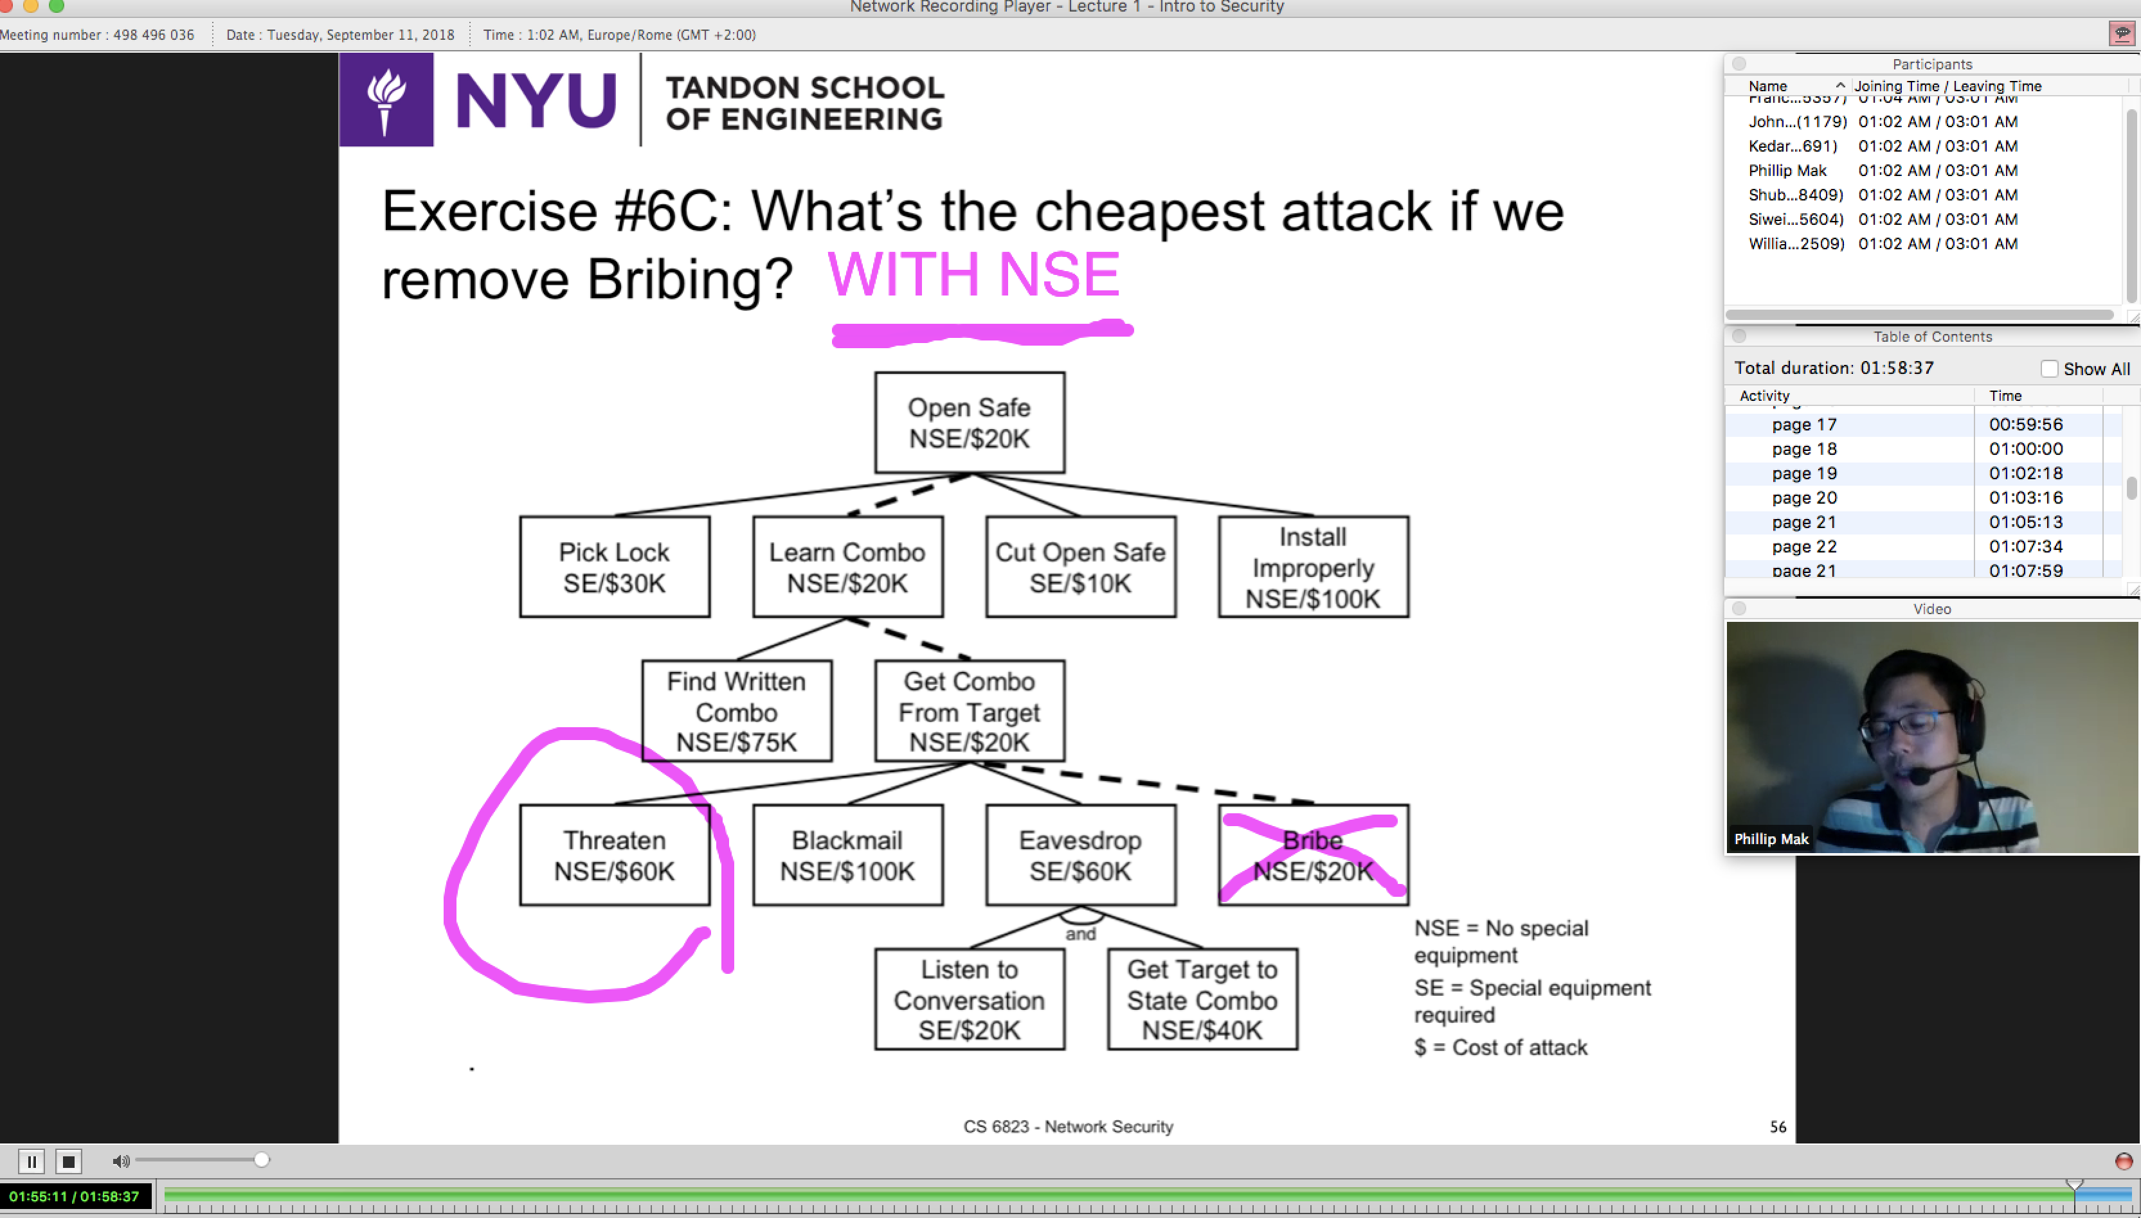

Week 2:

Today’s systems are extremely dependent on one another

CIA AN

Risk Management and Risk Assessment

Qualitative Reasoning vs Quantitative Reasoning

Security is an ongoing process, required maintenance

Attack Tree to identify weaknesses

Try to follow the philosophy that attackers will attack the lowest hanging fruit

Exploiting Systems

Need to gain authorization from a company to penetration test

CISO or CIO can give you authorization

Network Attack Methodology

Recon

Gain information about target

Scanning

Identifying hosts on a network

Vulnerability Identification

Exploitation

Gaining Access

Elevating given access  
 Application / Web Level Attacks

Denial of Service

Post Exploitation

Maintaining Access

Removing Forensics

Exfiltration

RECONNAISSANCE

1. COLLECT PUBLIC INFORMATION FROM PUBLIC SOURCES (GOOGLE)
2. FIND OUT THE NETWORK THAT THE TARGET IS ON
3. FIND THE HOST THE TARGET IS ON
4. SERVICE DISCOVERY
5. ANALYZE
6. RECURSION

Trying to get IP Address

Network Topology

Domain Names

User Account Names

Operating Systems

Security Policies

Physical Security

Home Address and Frequent Hangouts

COLLECT PUBLIC INFORMATION

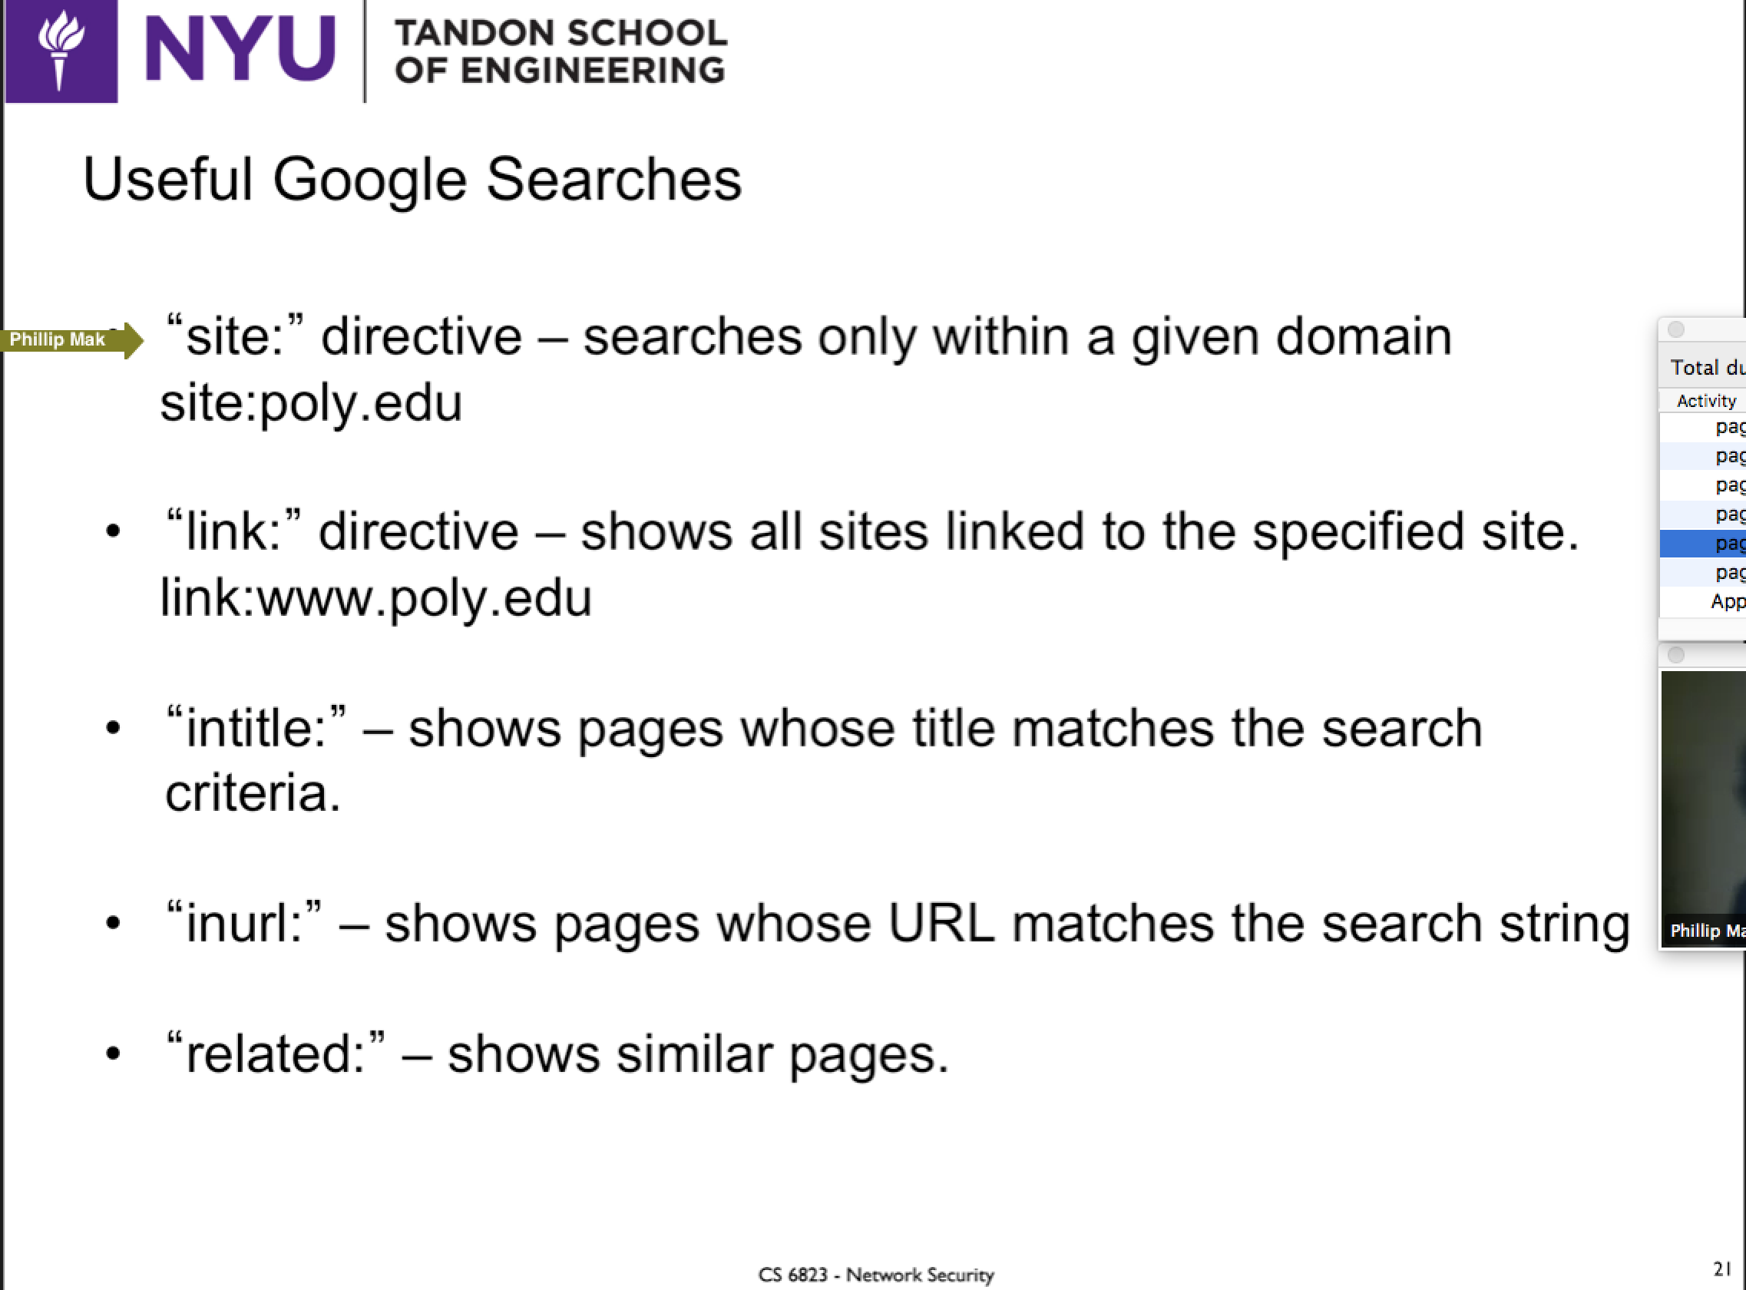

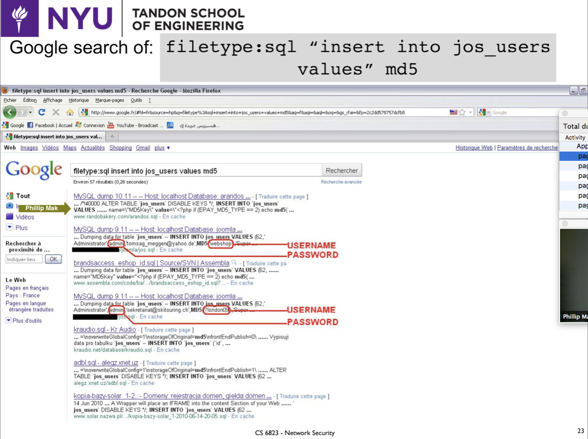

**DETERMINING NETWORK RANGE**

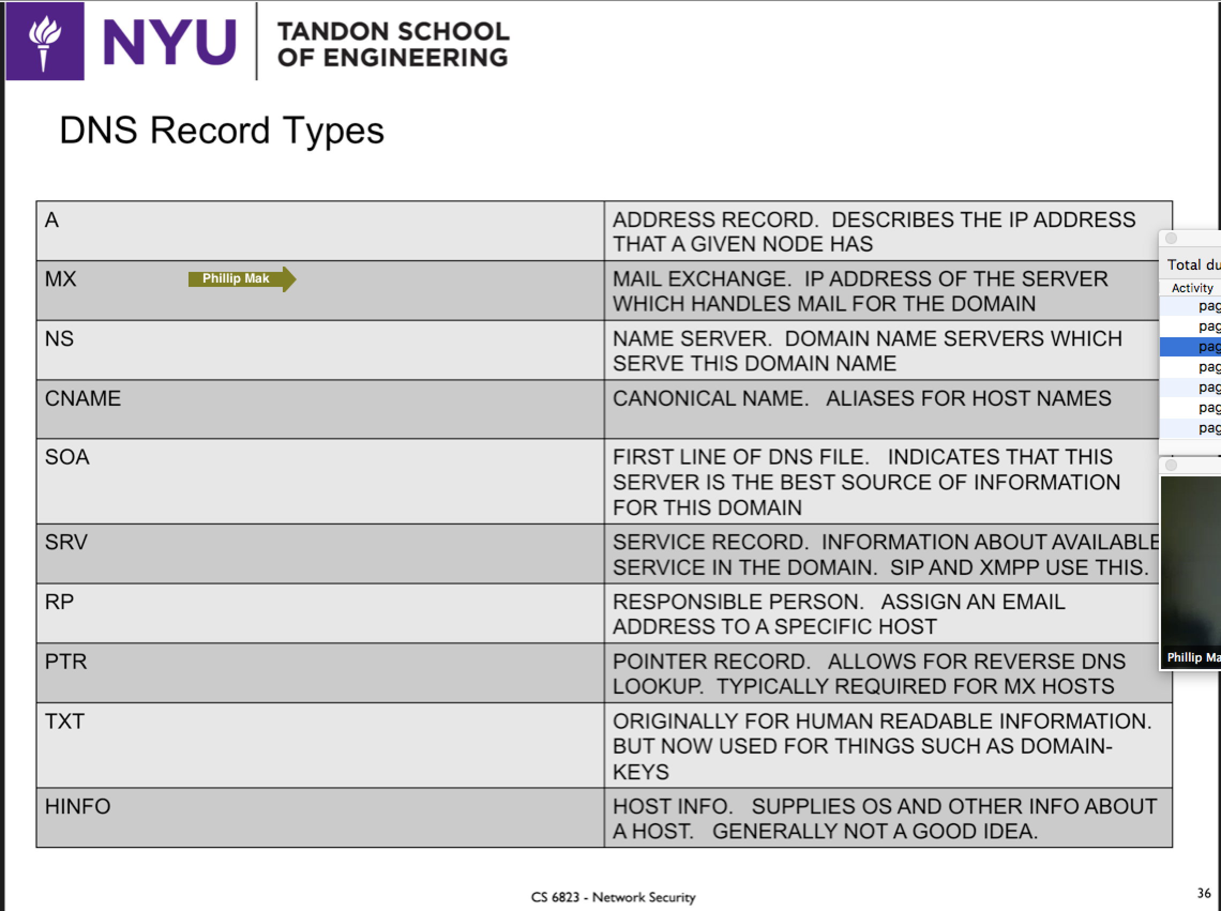

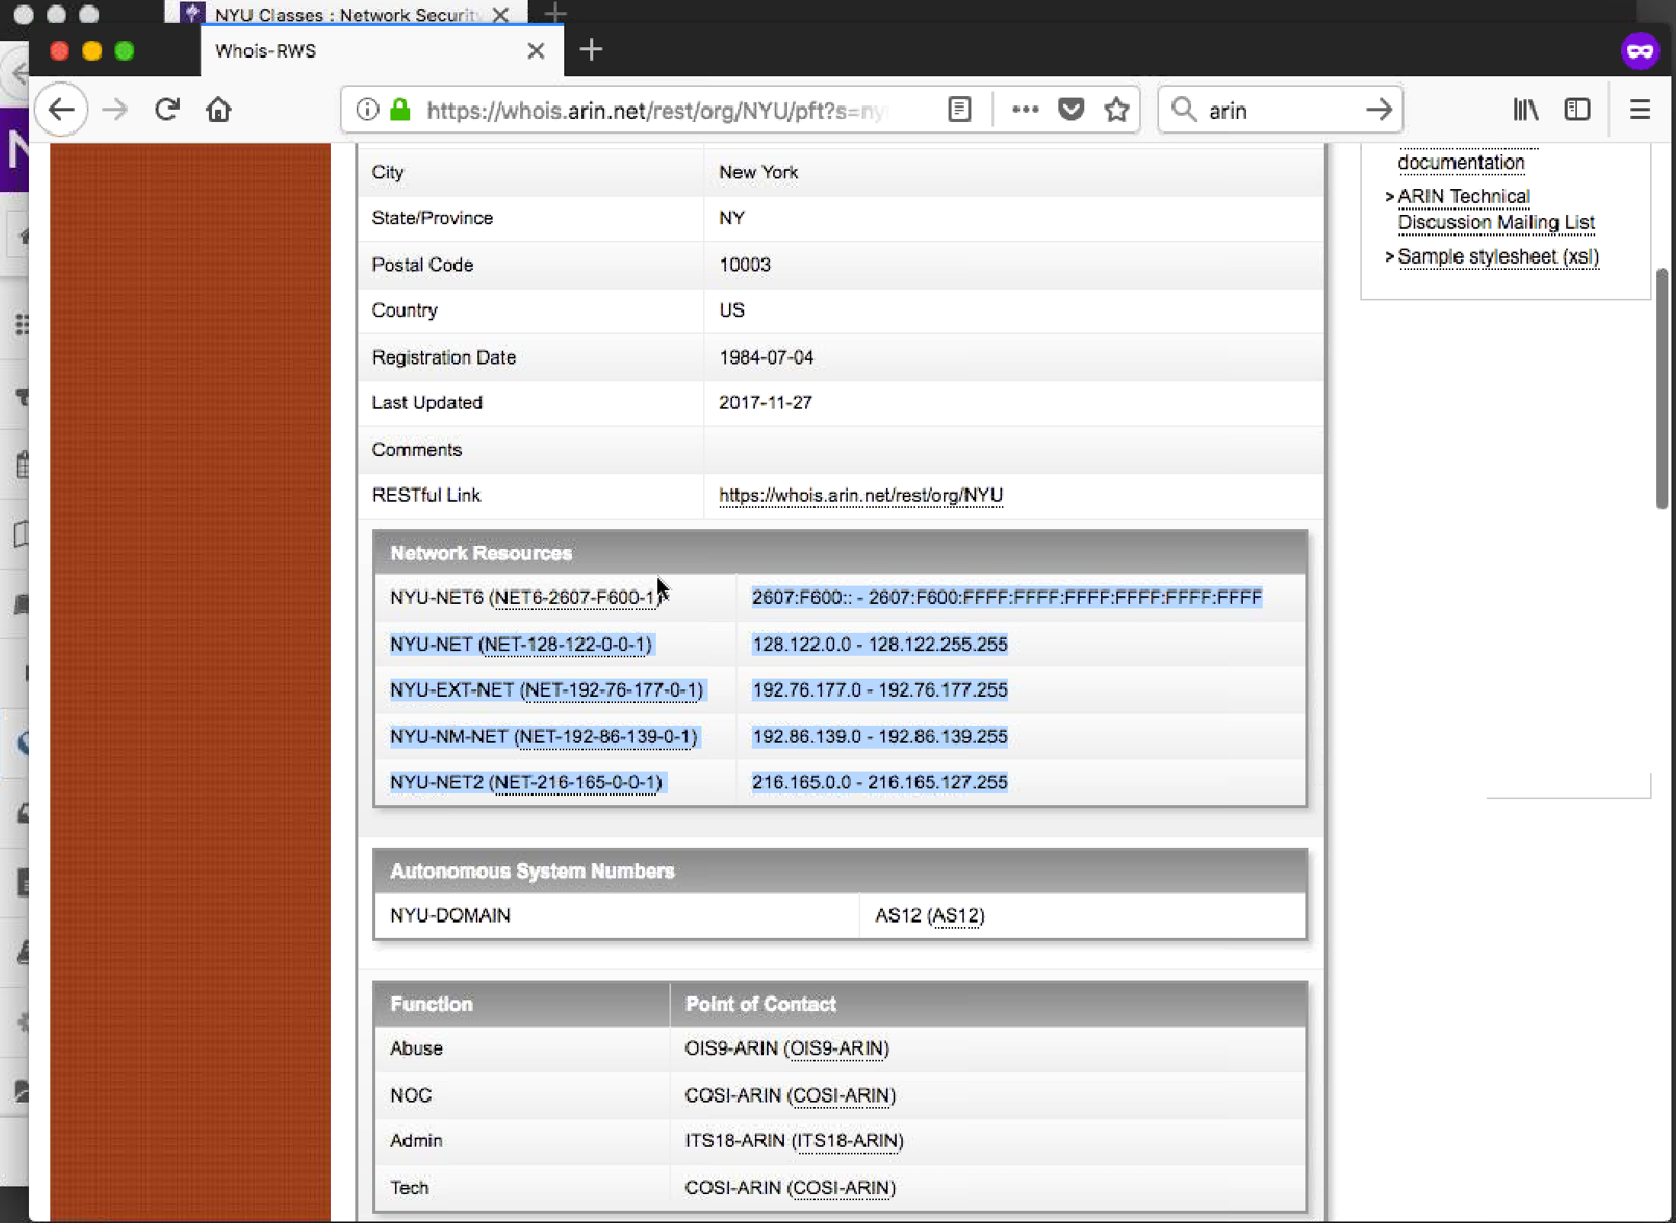

**WHOIS ARIN**

**WHOIS NETWORK SOLUTIONS**

**DNS MXTOOLBOX**

**Mx:nyu.edu (Mail Server)**

**ROBTEX**

**ULTRATOOLS TRACEROUTE**

**SHODAN**

**DNS Zone Transfer, Gives all the information a website has (DEFAULT IS OFF)**

**Brute Force Forward DNS**

**SPLIT DNS TO COUNTER**

**TCP HAS TO HAVE A SEQ AND ACK**

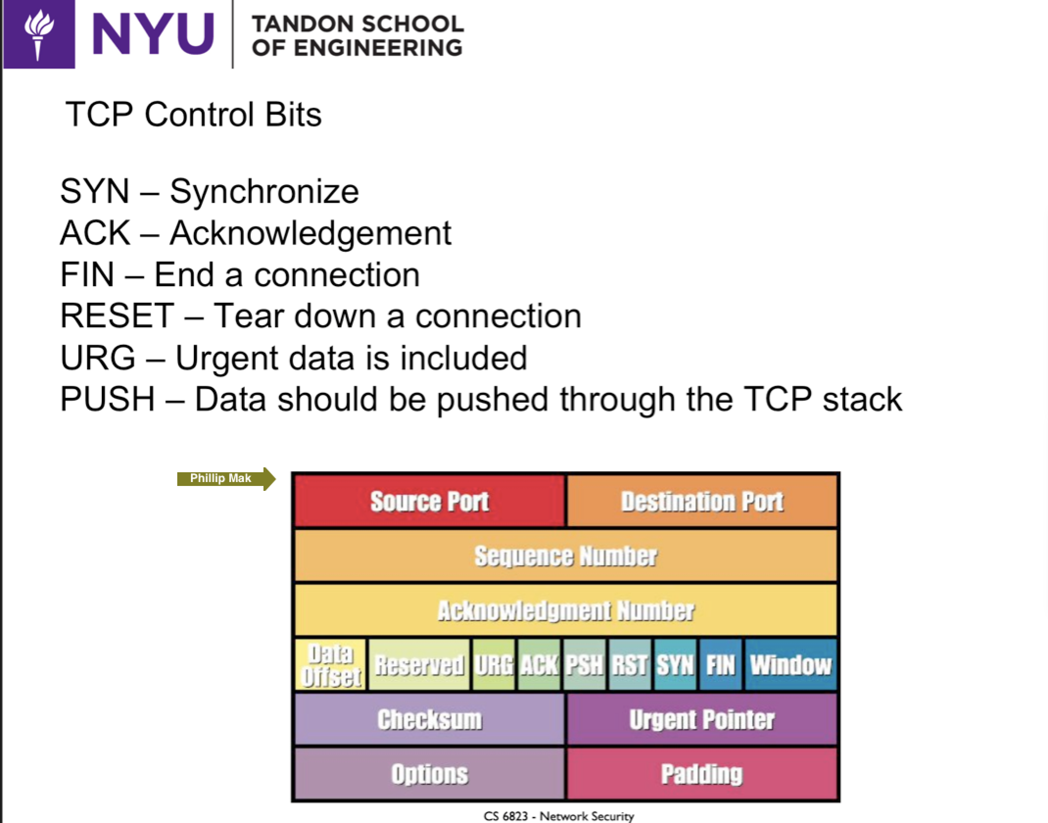

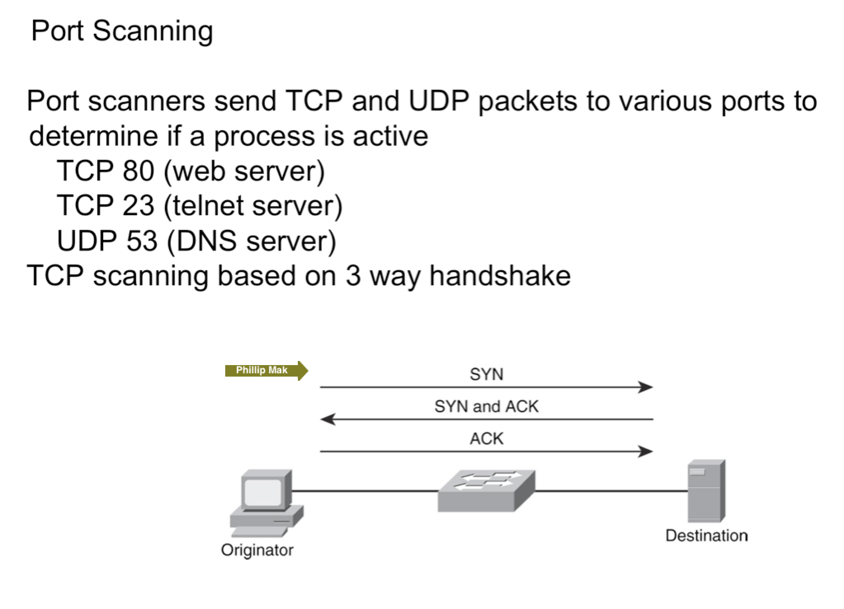

**TCP 3 WAY HANDSHAKE IF PORT IS OPEN**

**TCP SYN**

**SOURCE PORT: 1024+**

**DESTINATION PORT: 80**

**TCP SYN/ACK**

**SOURCE PORT: 80**

**DESTINATION PORT: 1024+ (SAME AS BEFORE)**

**TCP ACK OR SYN/ACK ACK**

**SOURCE PORT: 1024+**

**DESTINATION PORT: 80**

**END CONNECTION**

**TCP FIN**

**TCP FIN/ACK**

**TCP ACK**

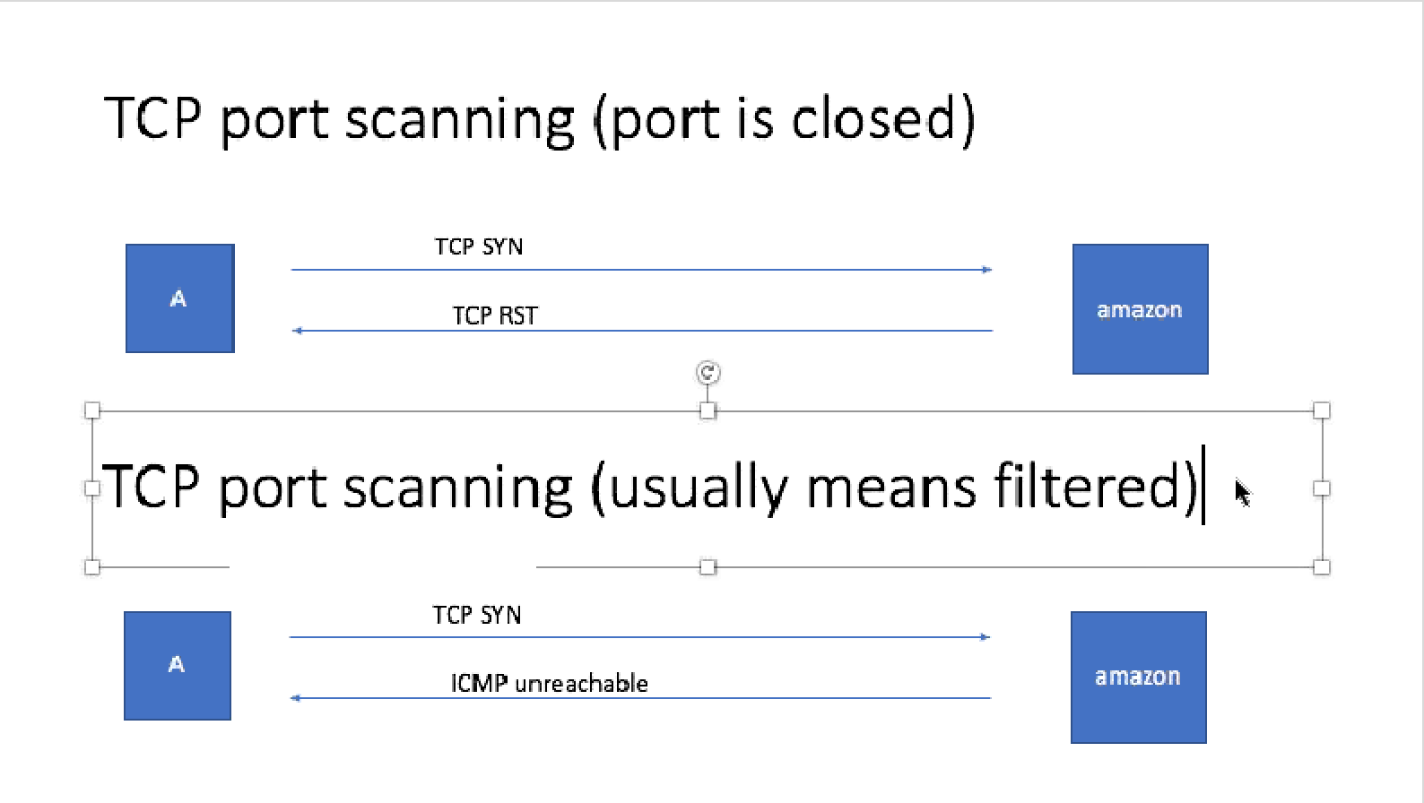

**IF YOU GET NO RESPONSE AT ALL, DEFINITE FIREWALL PREVENTION**

**WEEK 3:**

**NMAP is a good port scanning tool**

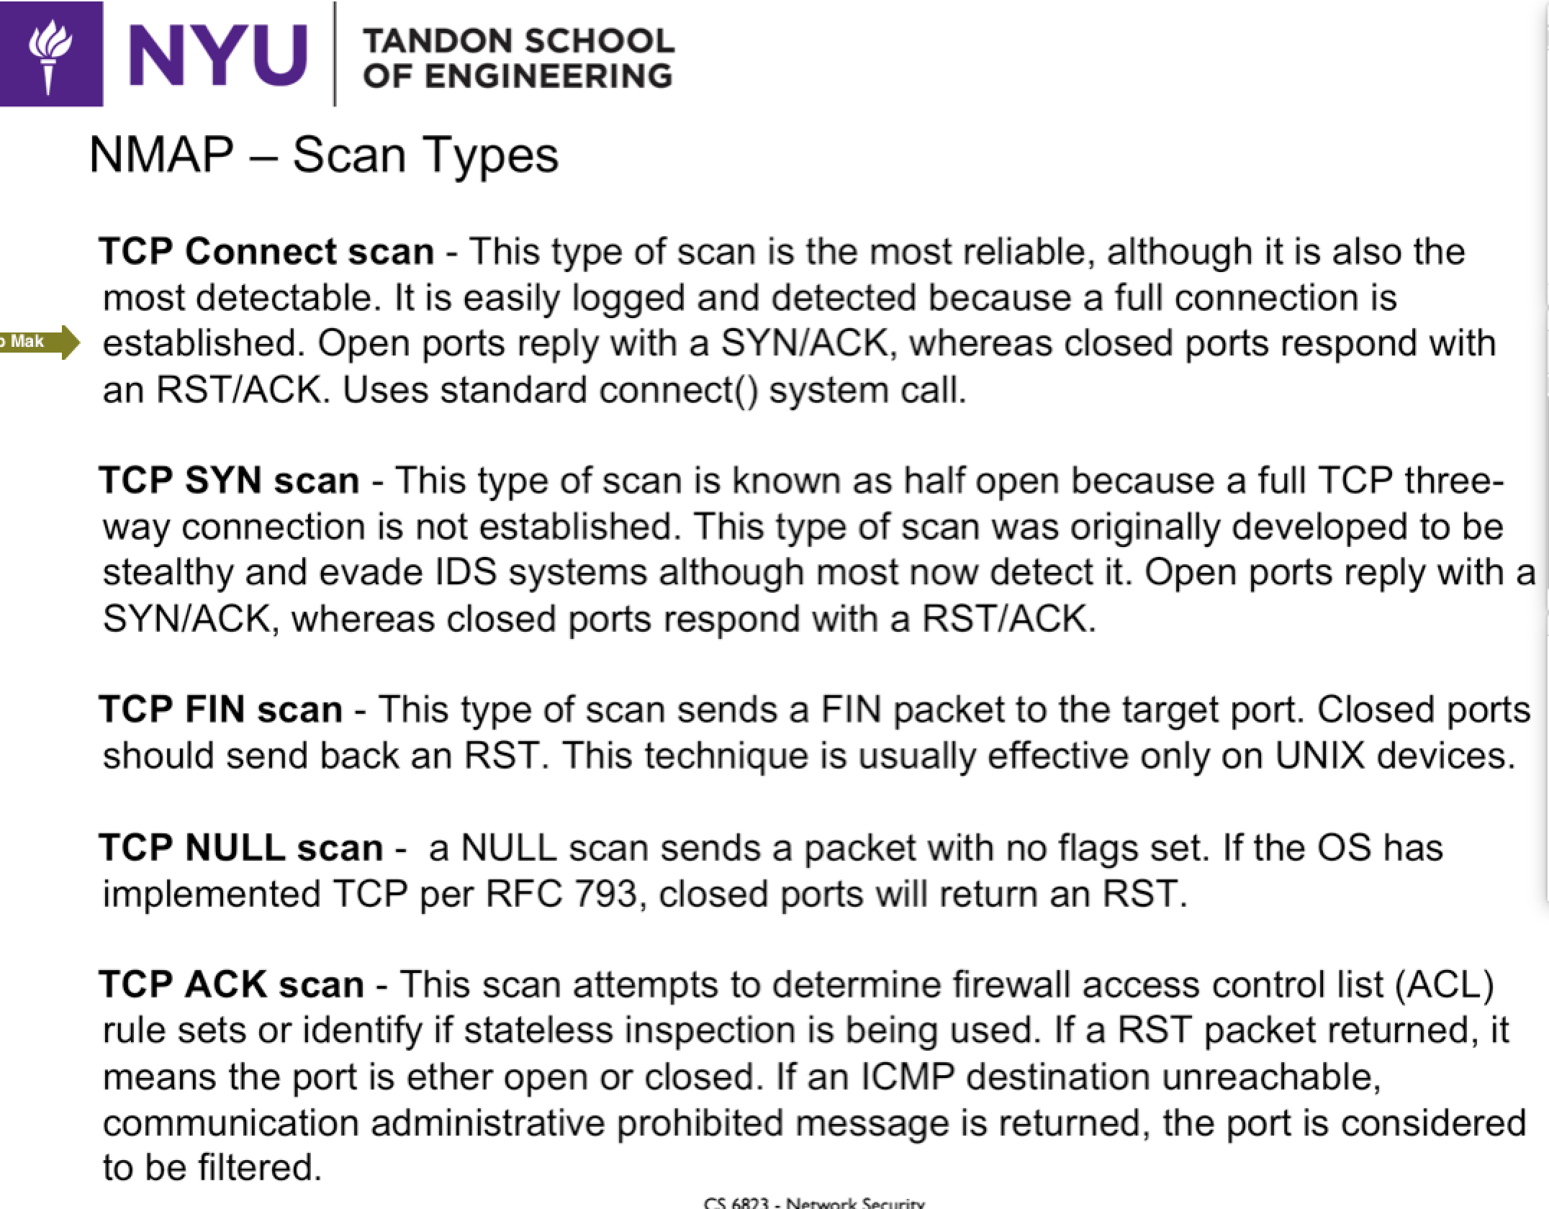

**TCP CONNECT SCAN takes a while, establishes the connection with 6 packets**

**TCP SYN SCAN is the most popular and best, only sends max 3. Gets a response, then closes the connection or if failed, just stops**

**TCP ACK SCAN sends a random ACK out of the blue**

**Will send a TCP RST Back which doesn’t tell you if the port is open or not**

**BUT if there is no response, that means that there is a firewall preventing the packet**

**FILTERED: Firewall is in the way**

**TCP SYN AND ACK SCAN**

**First send a TCP SYN, get a reset (Means closed or firewall)**

**Then send Ack, no response, now sure there’s a firewall**

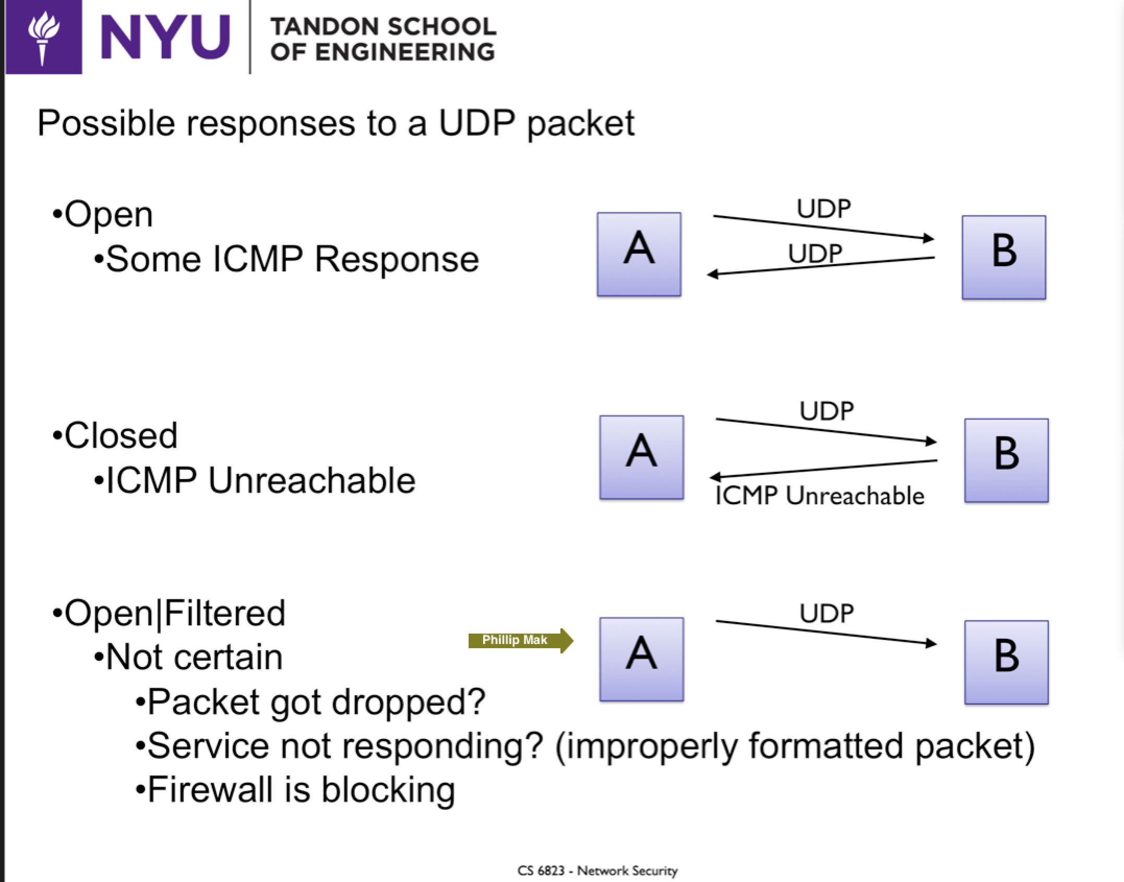

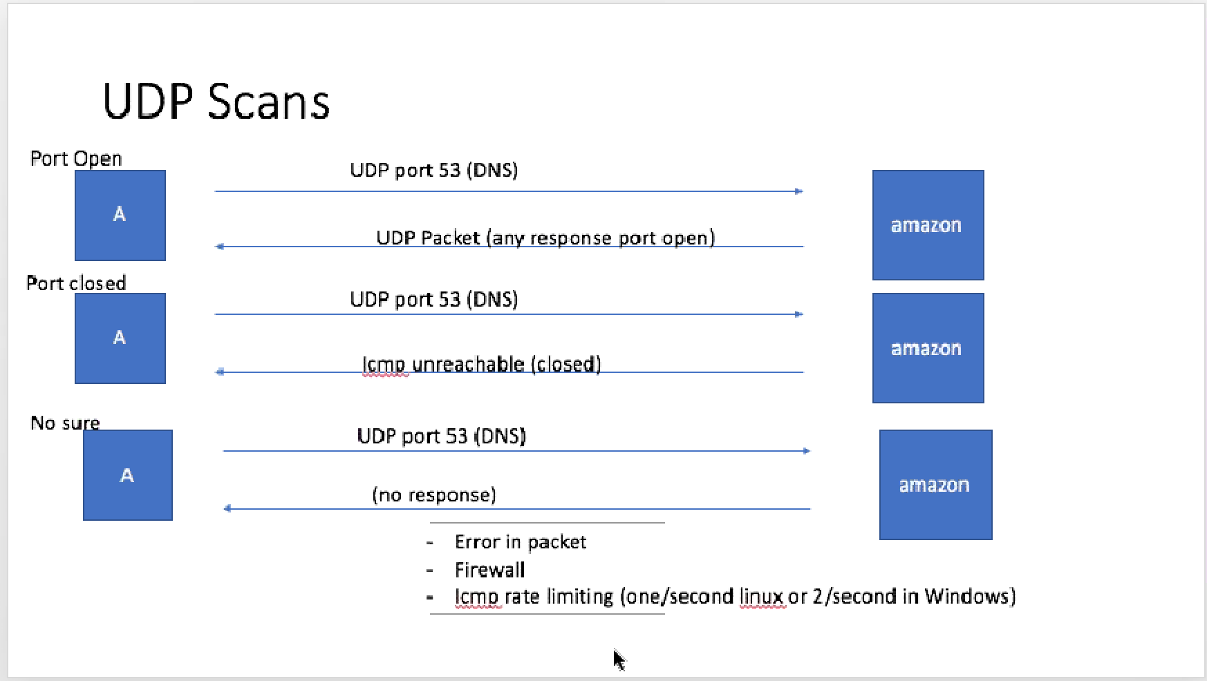

**MUST KNOW THE EXACT FORM OF PORT TO SEND**

**ONLY 1 PACKET / SECOND ~ 8 HOURS**

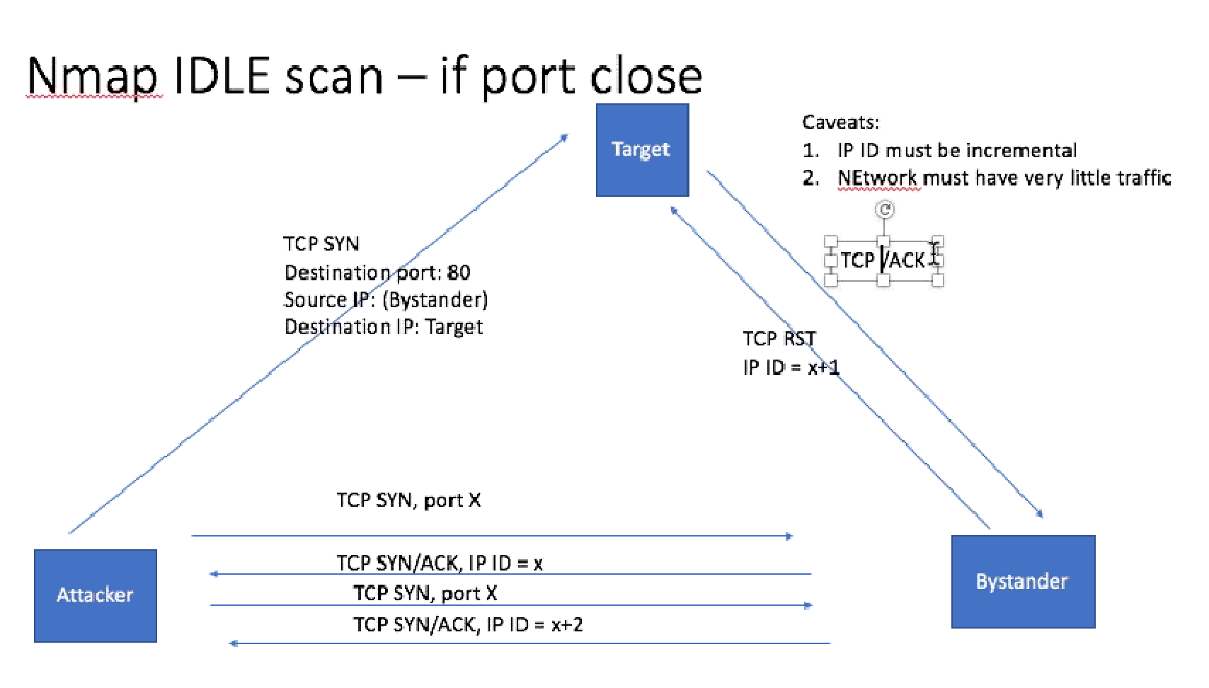

**IMPORTANT COMMANDS ON EXAM**

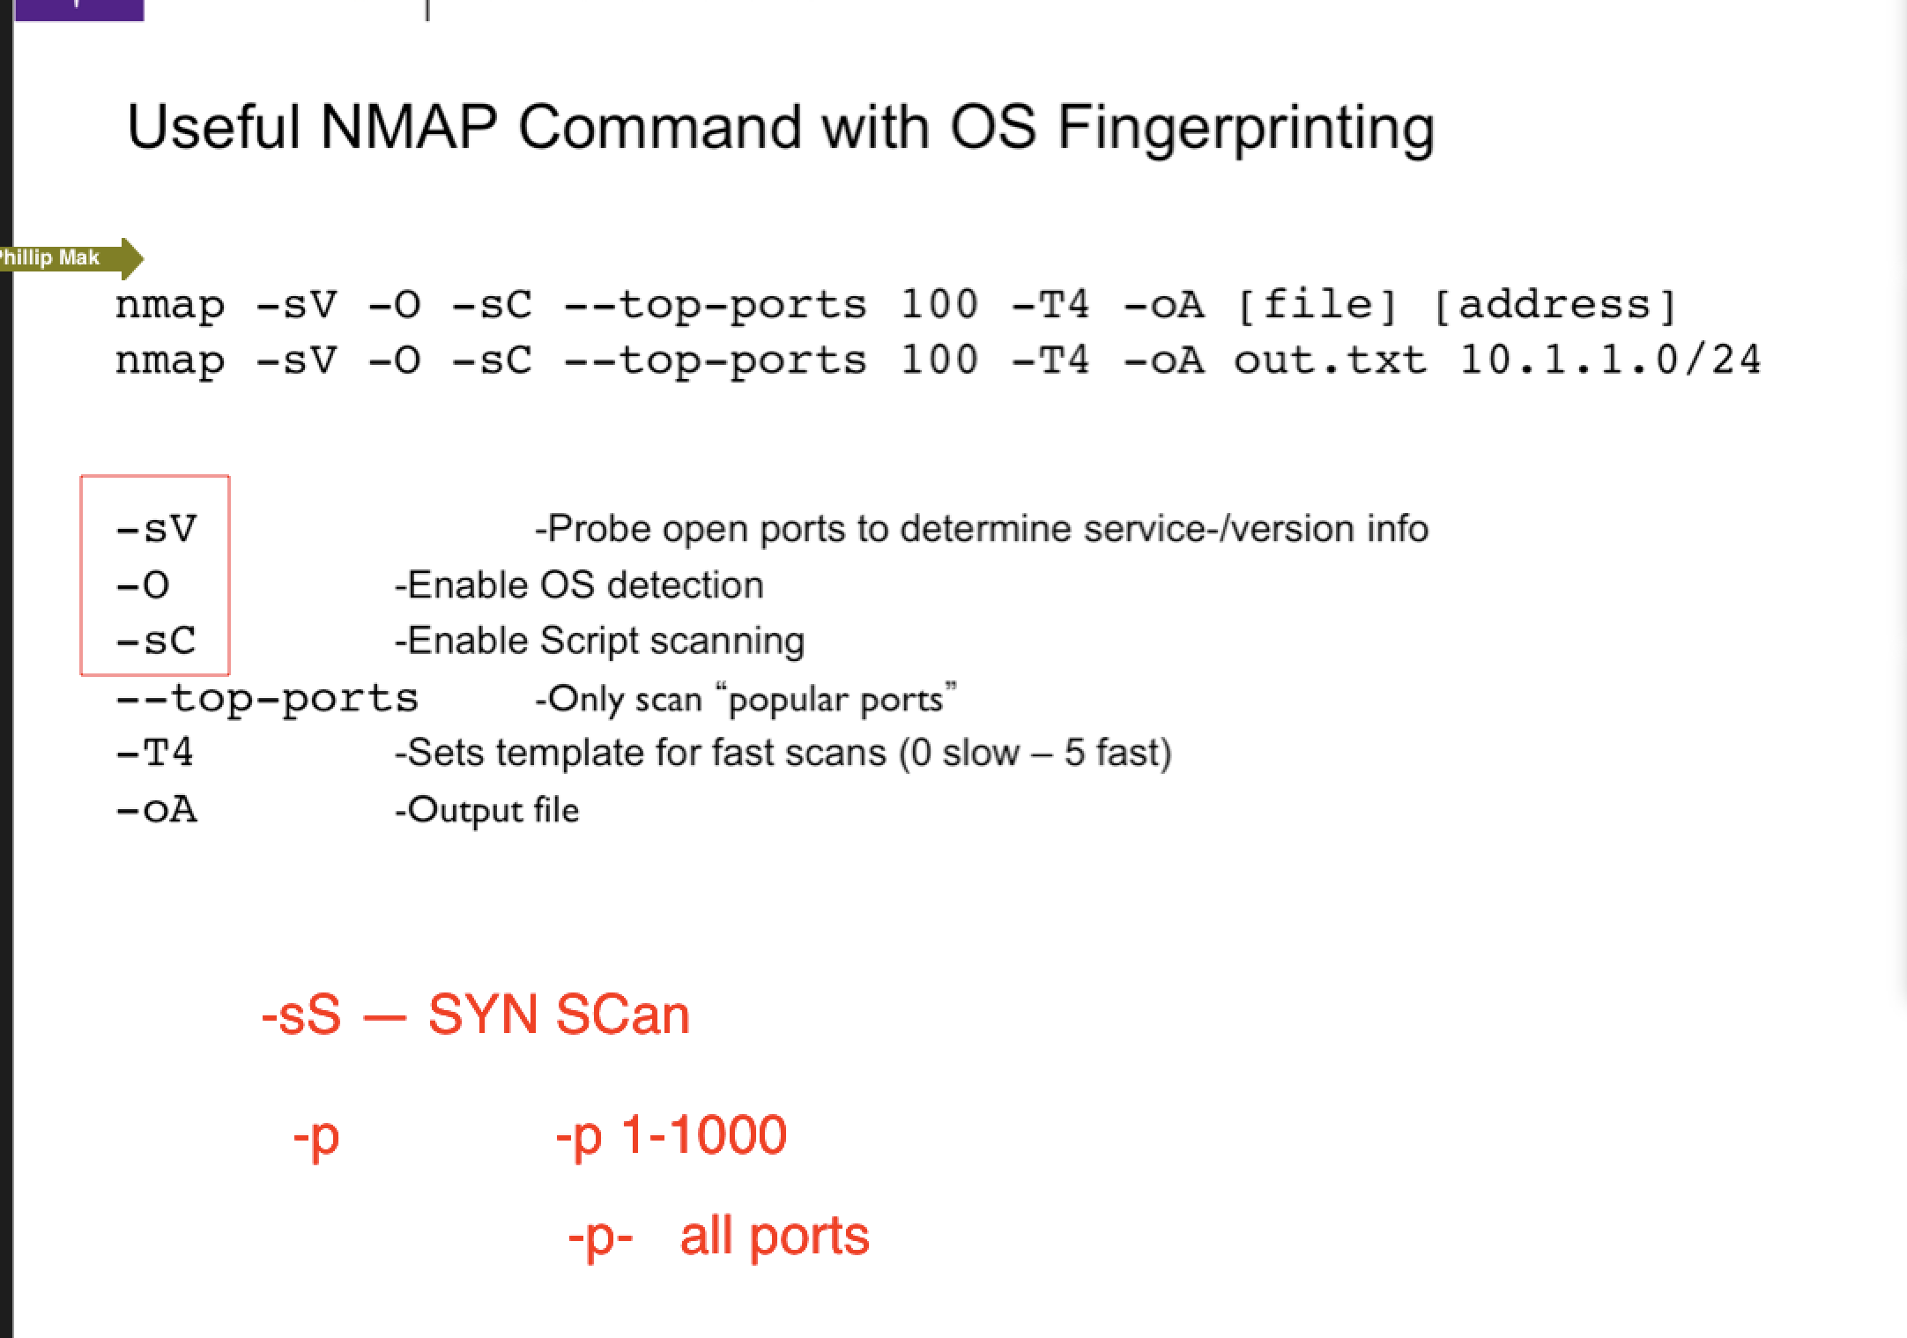

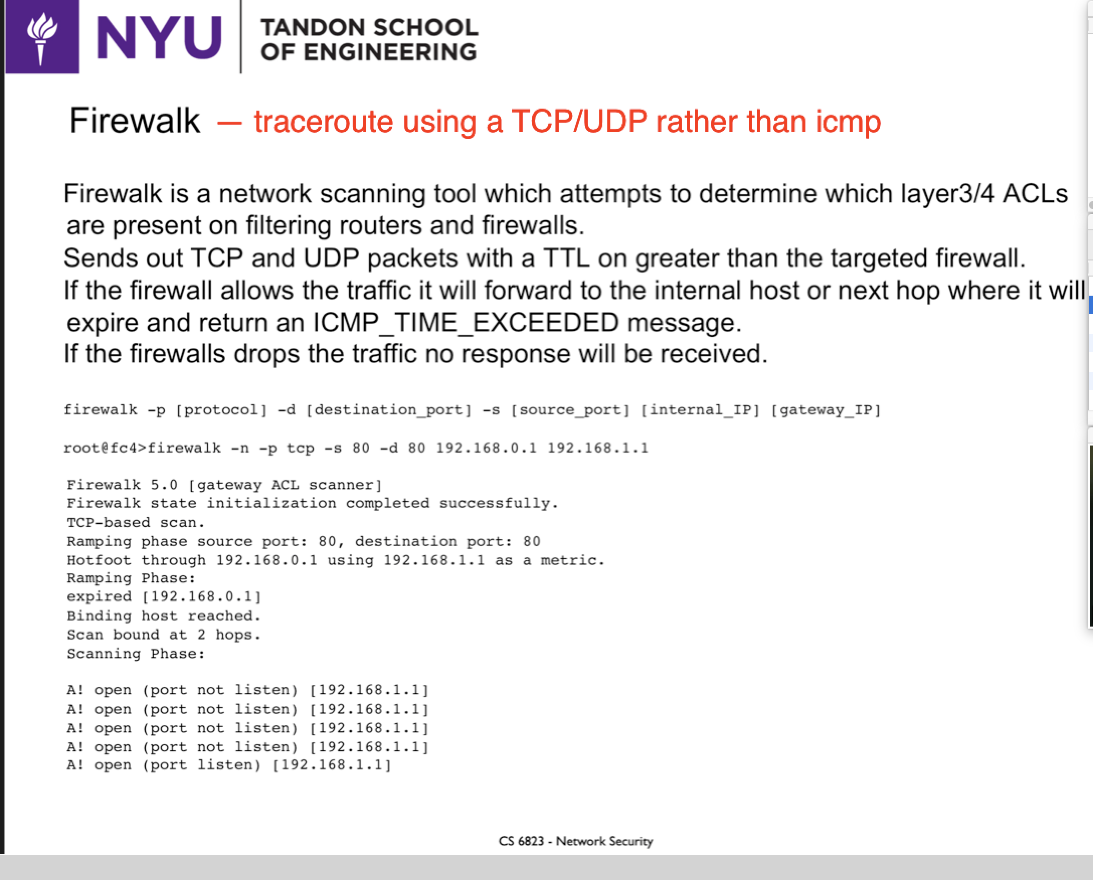

**WEEK 4:**

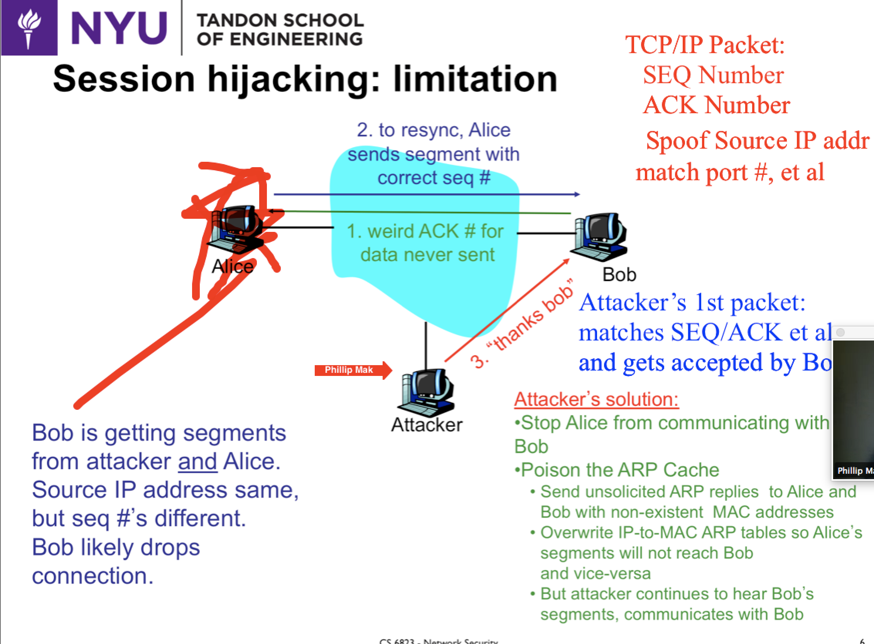 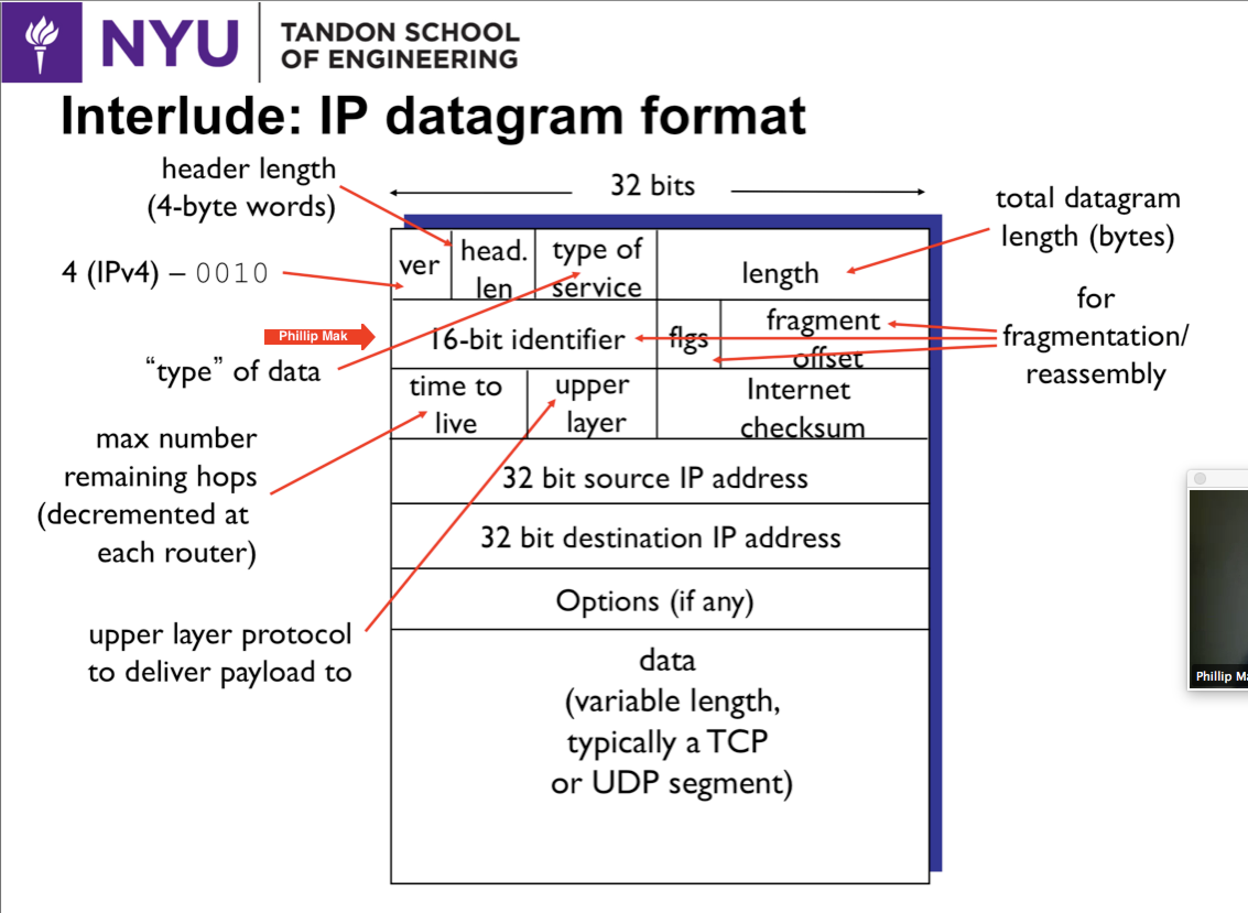

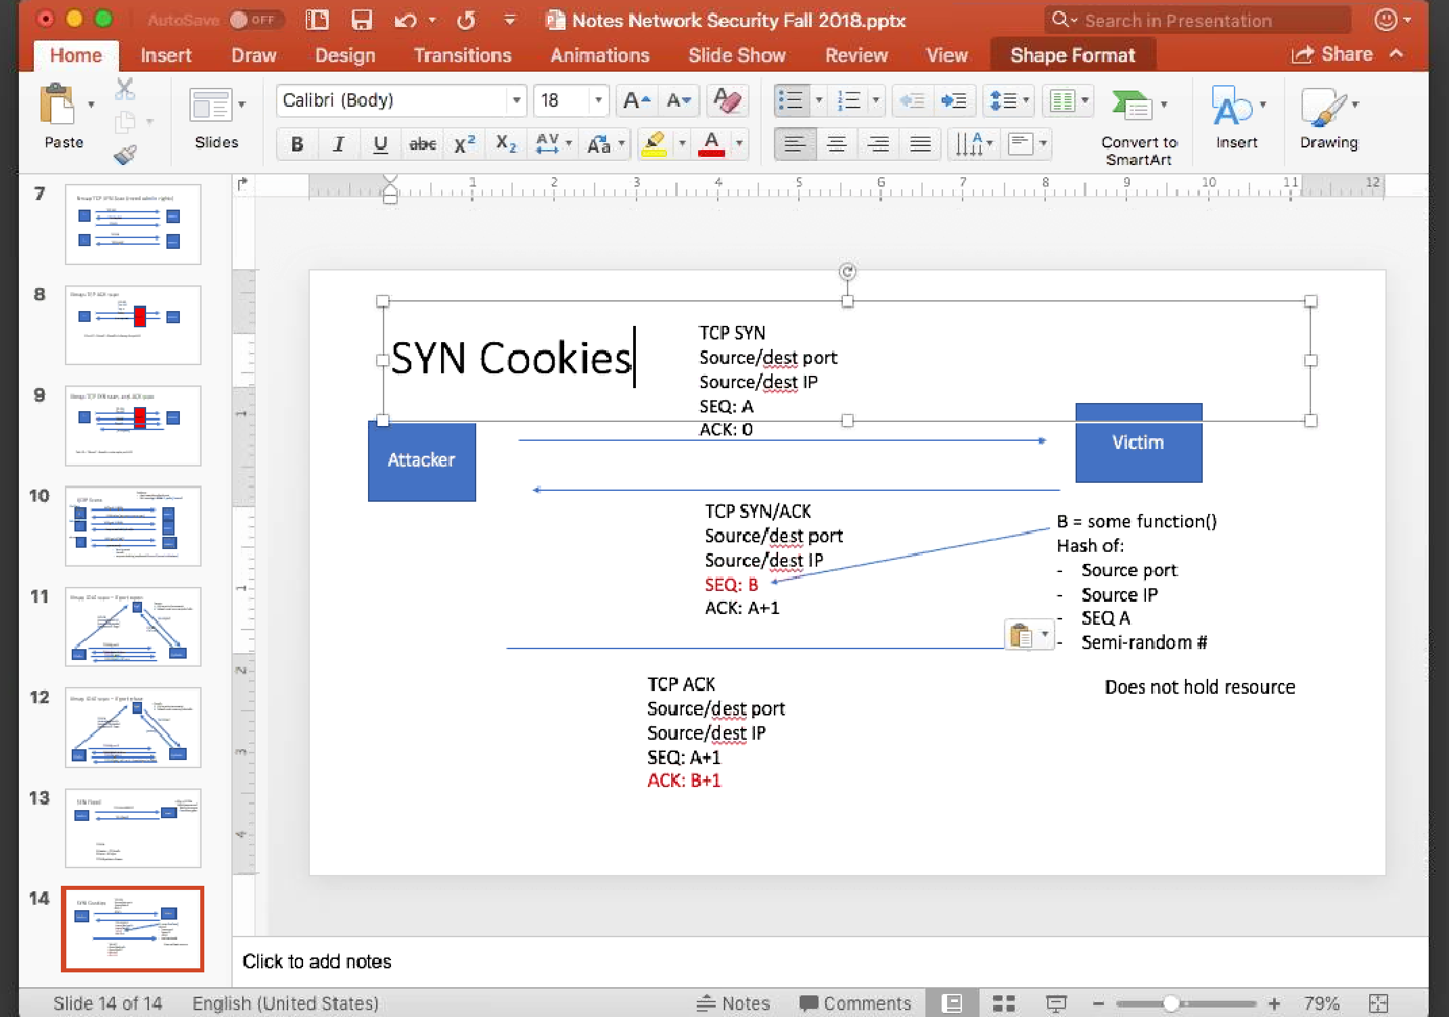

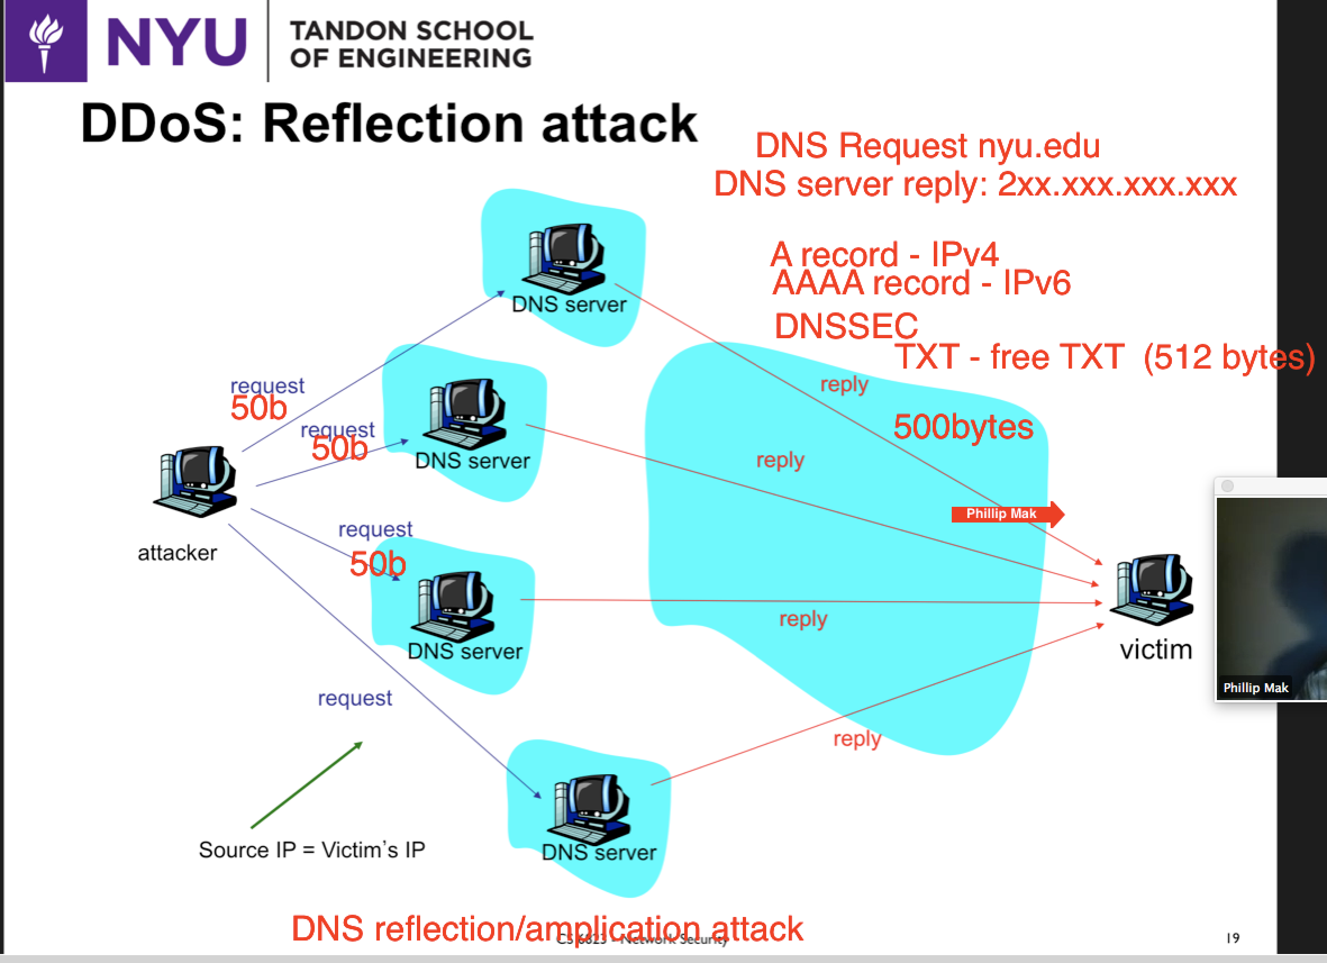

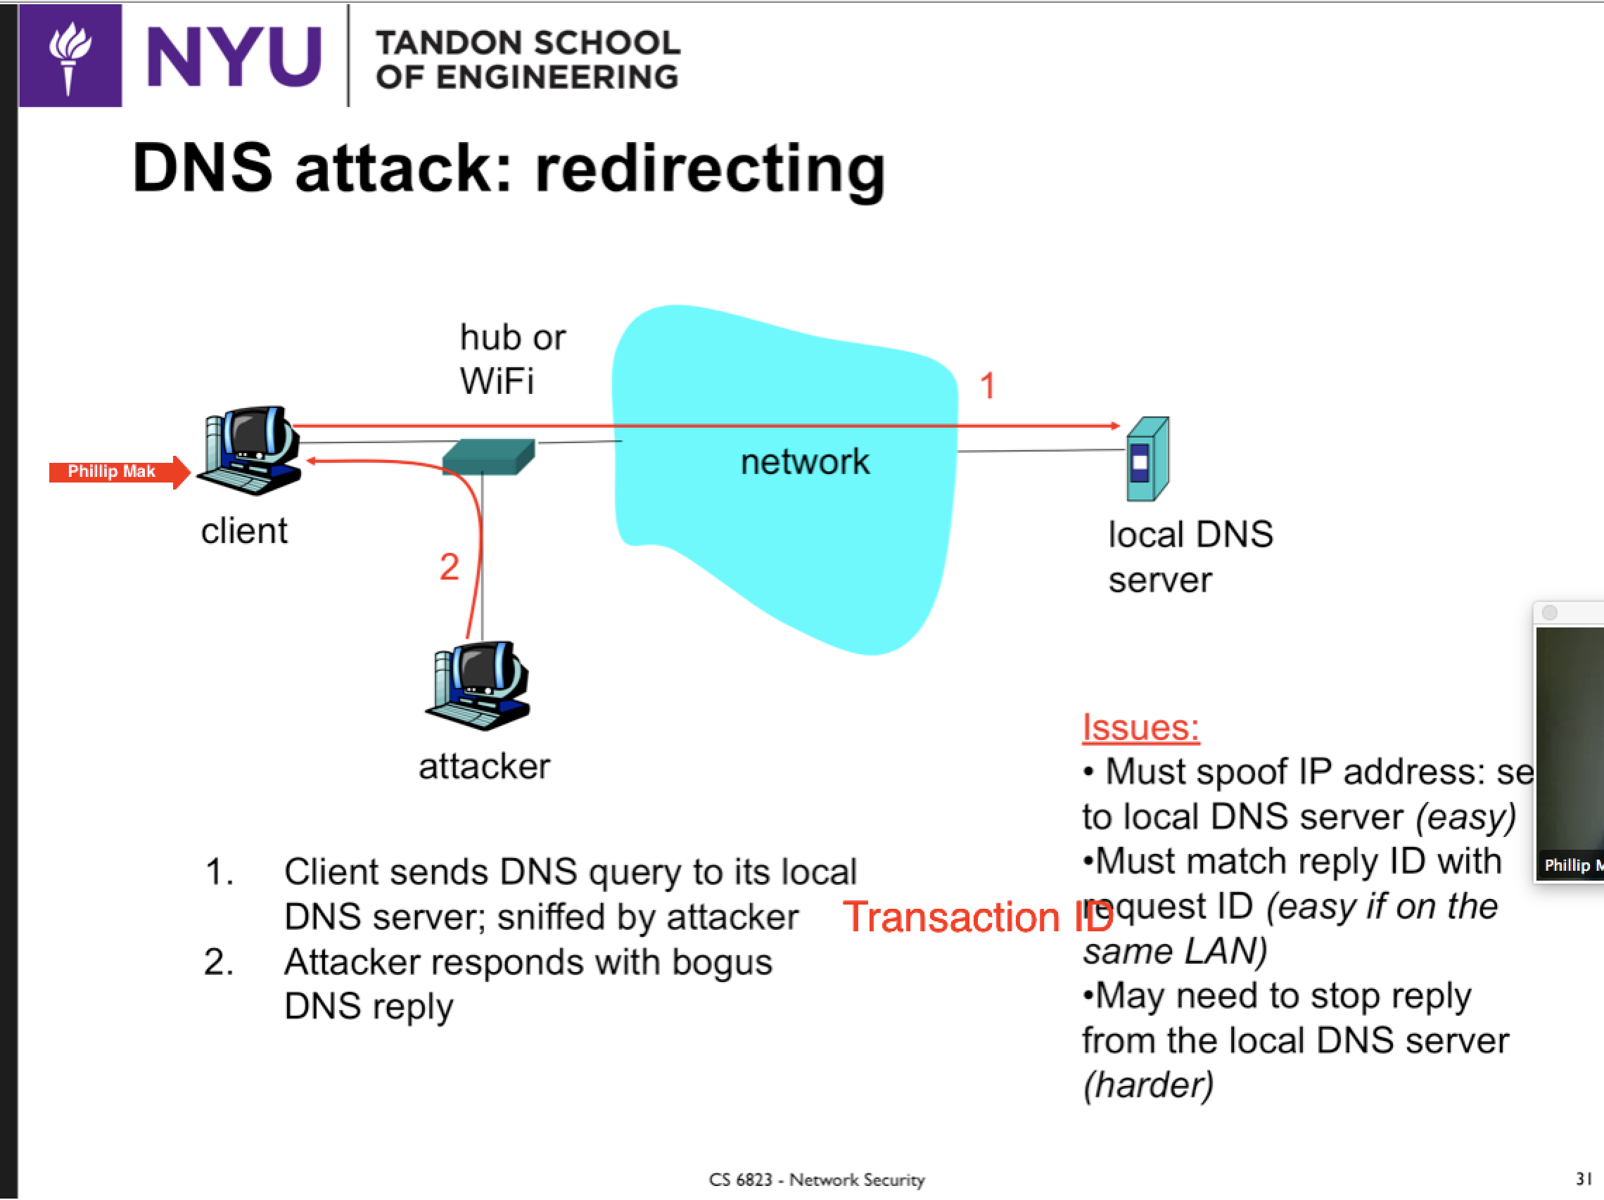

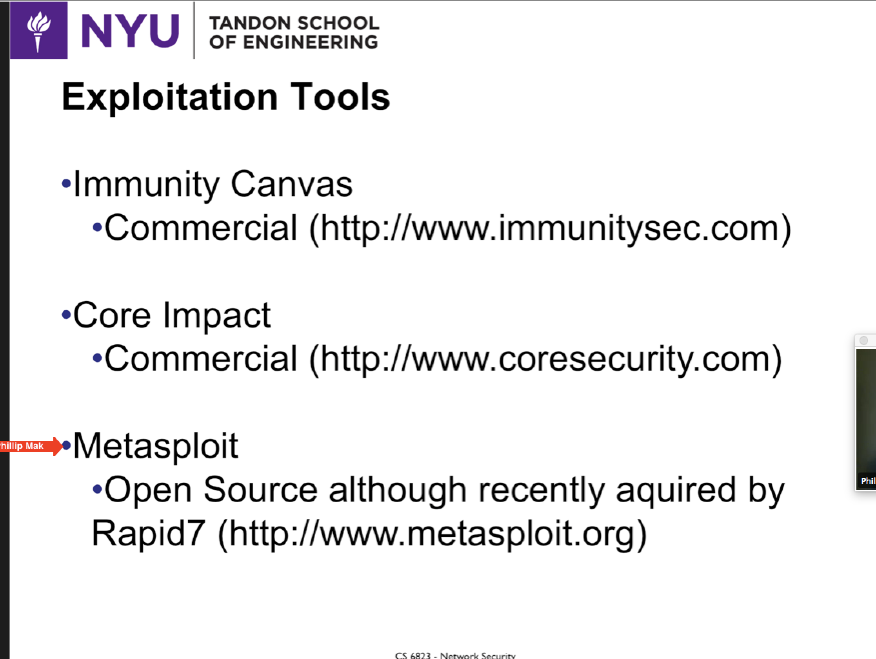

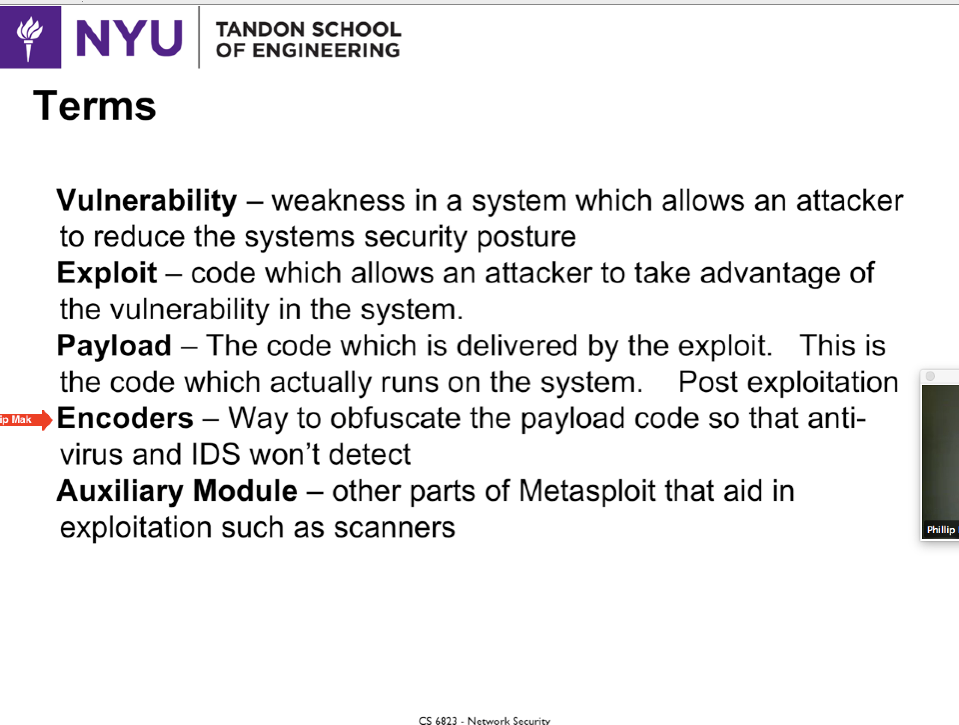

**External Router -> Internal Router**

**KALI = BT5**

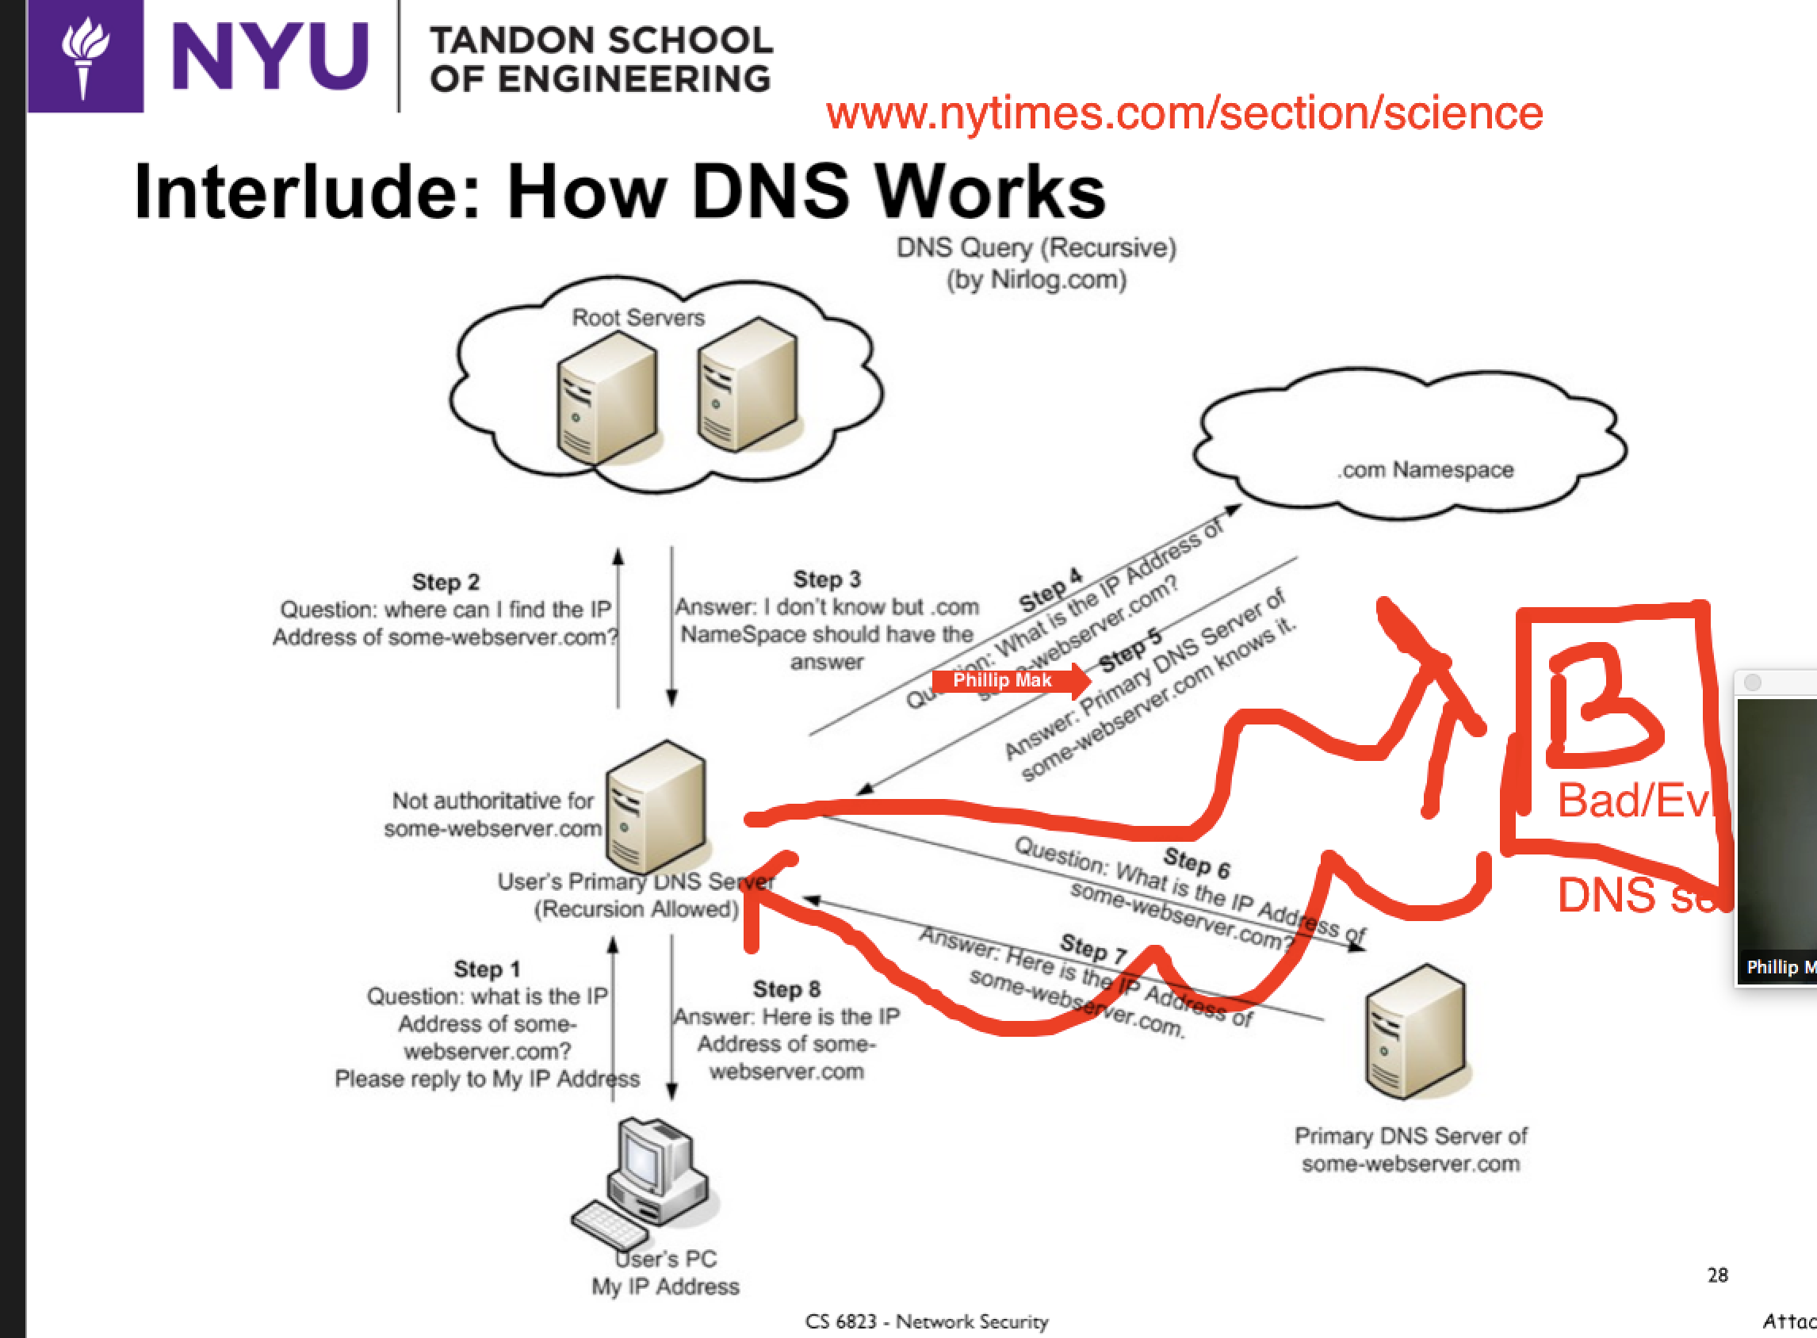

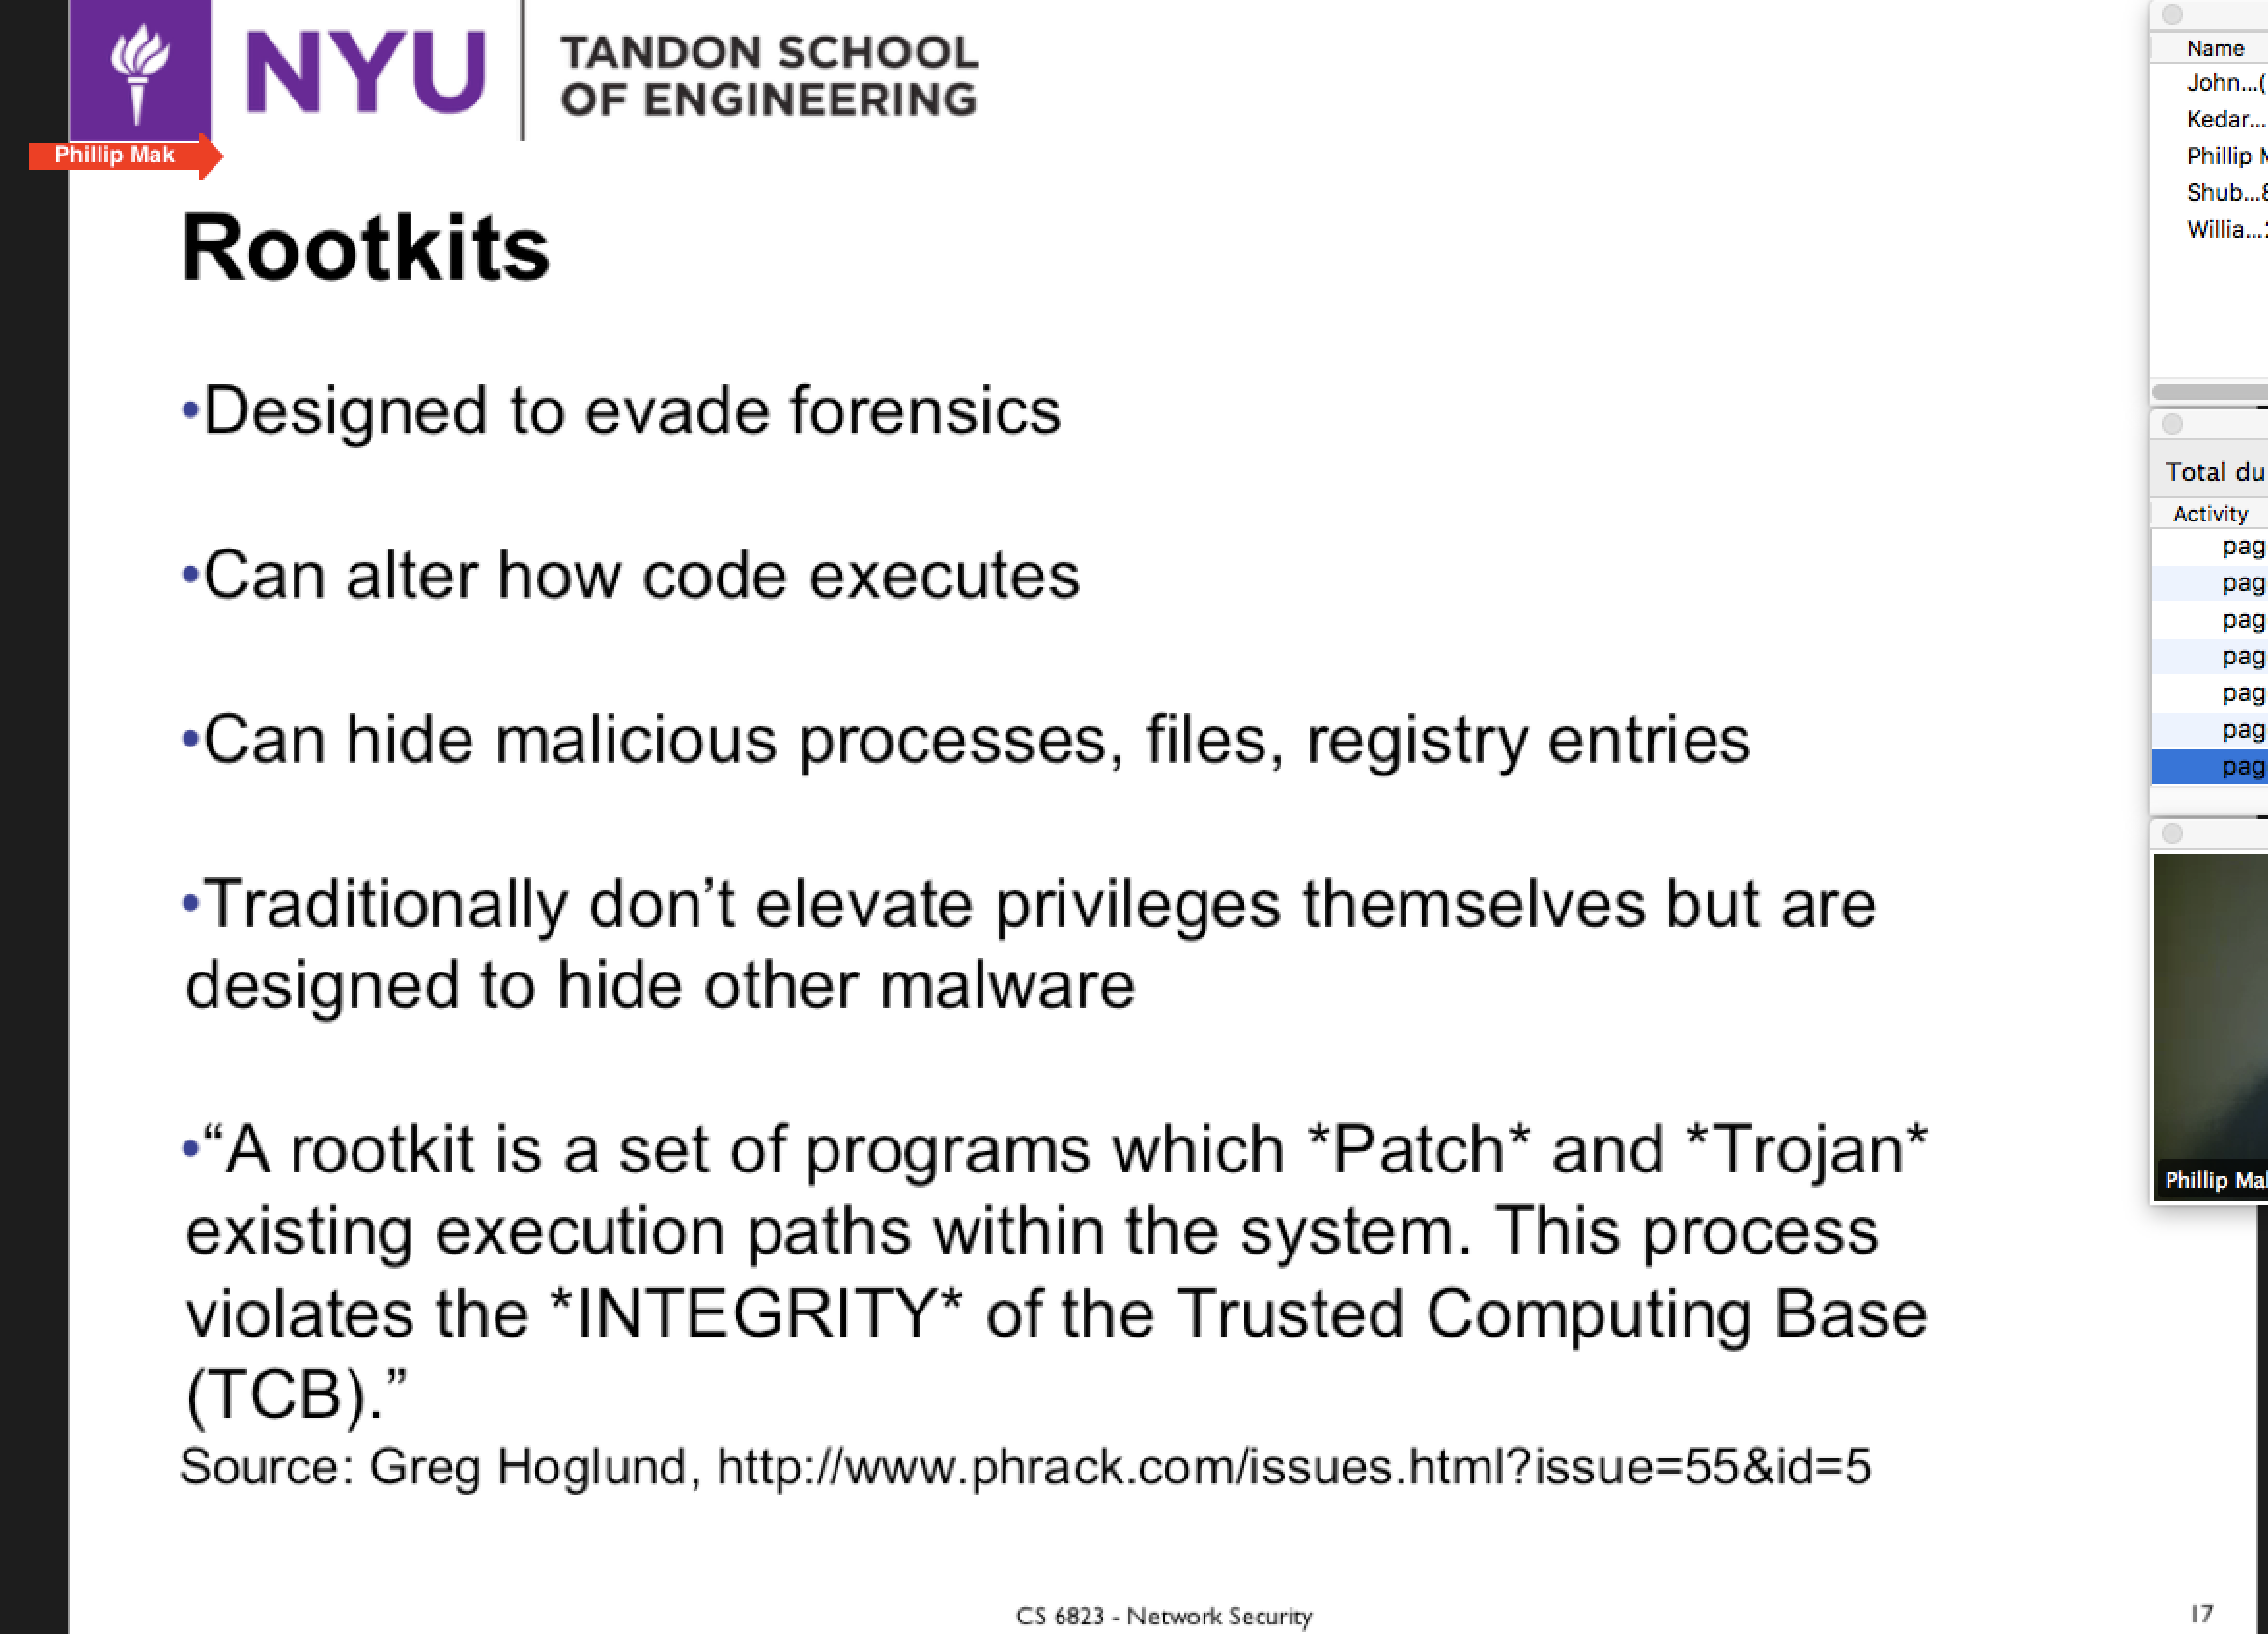

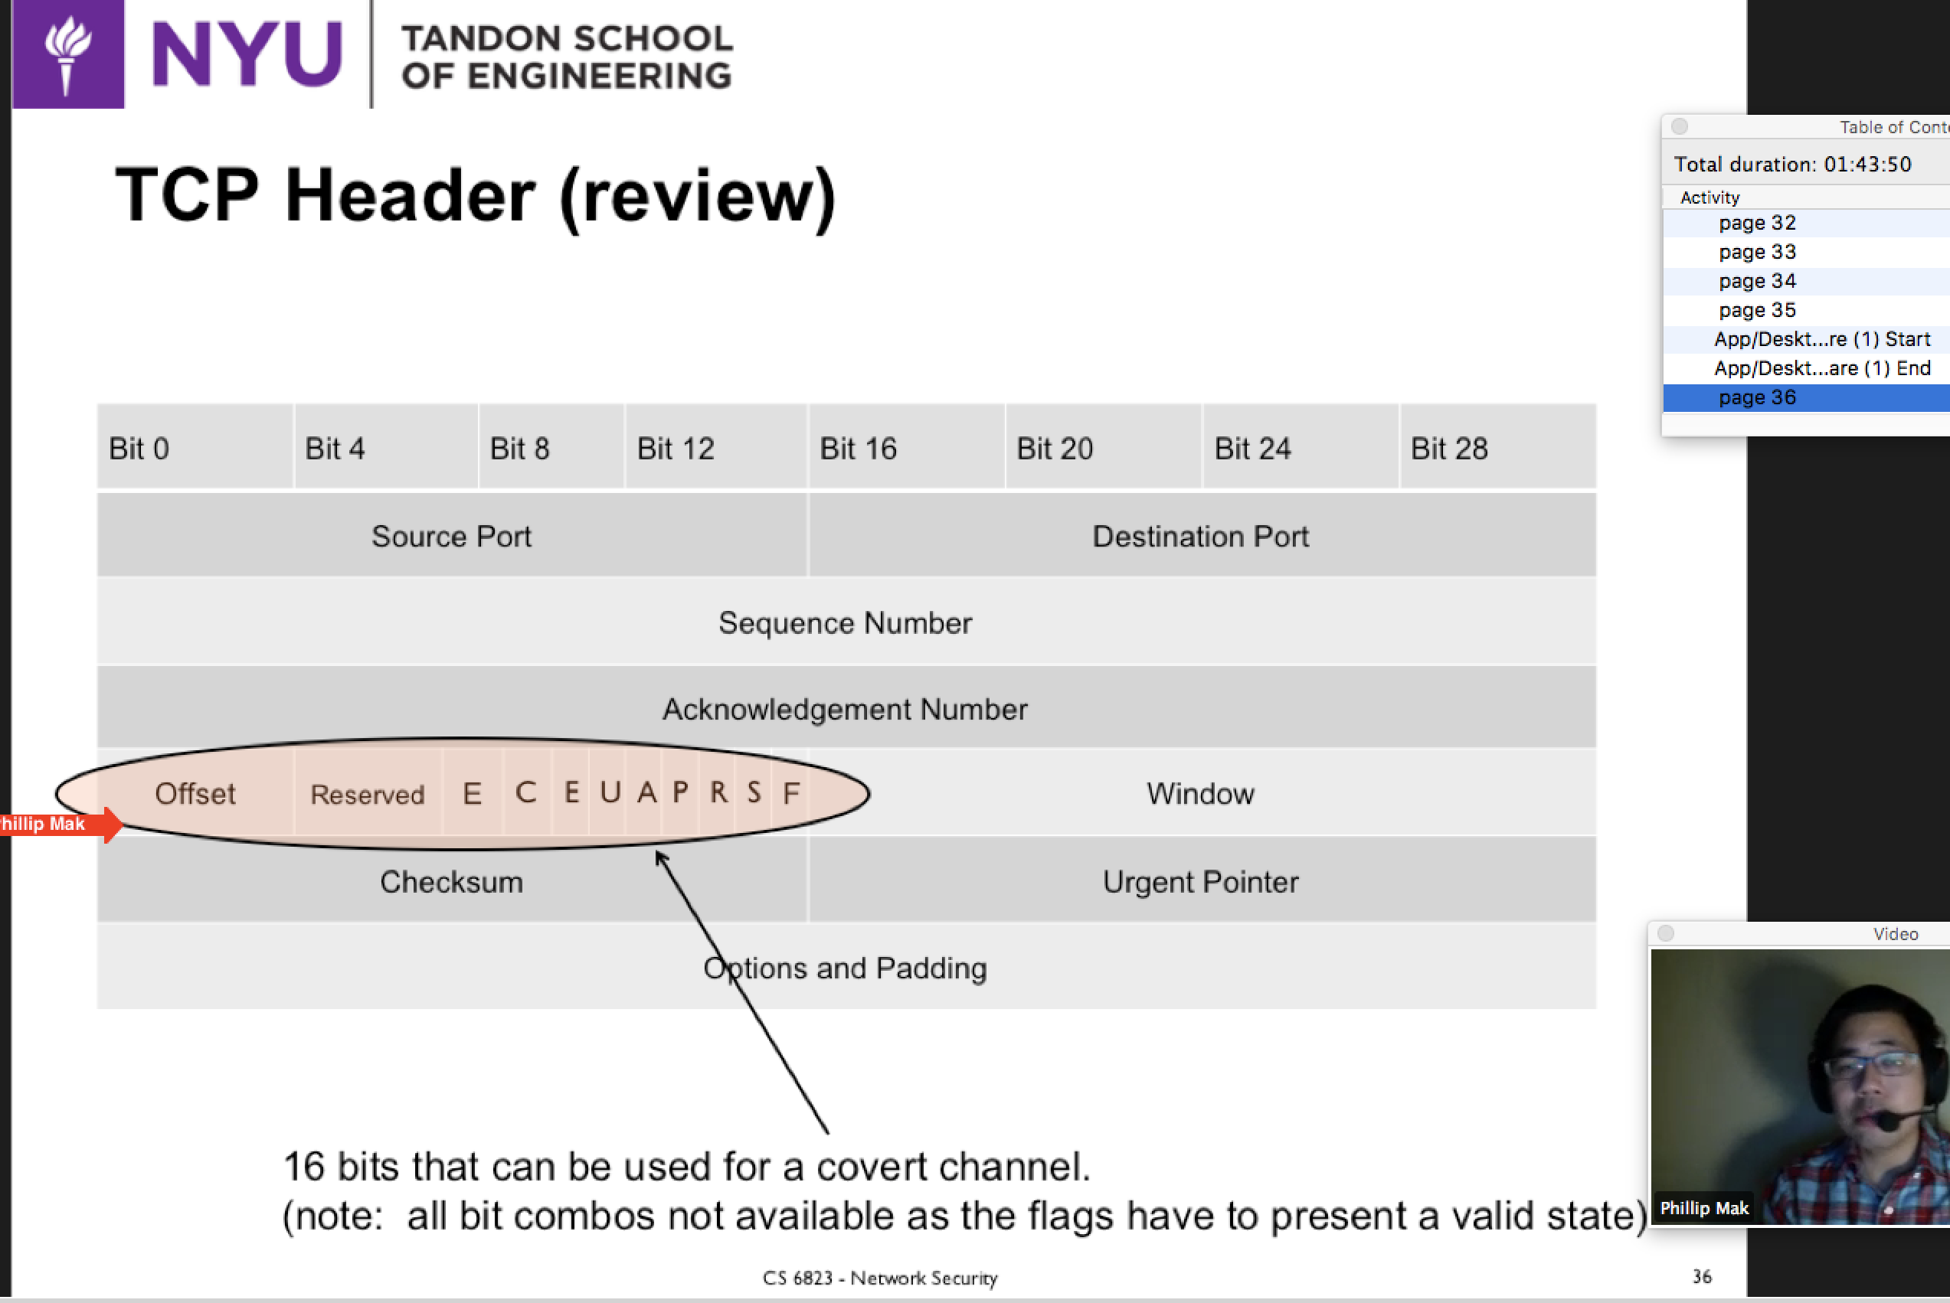

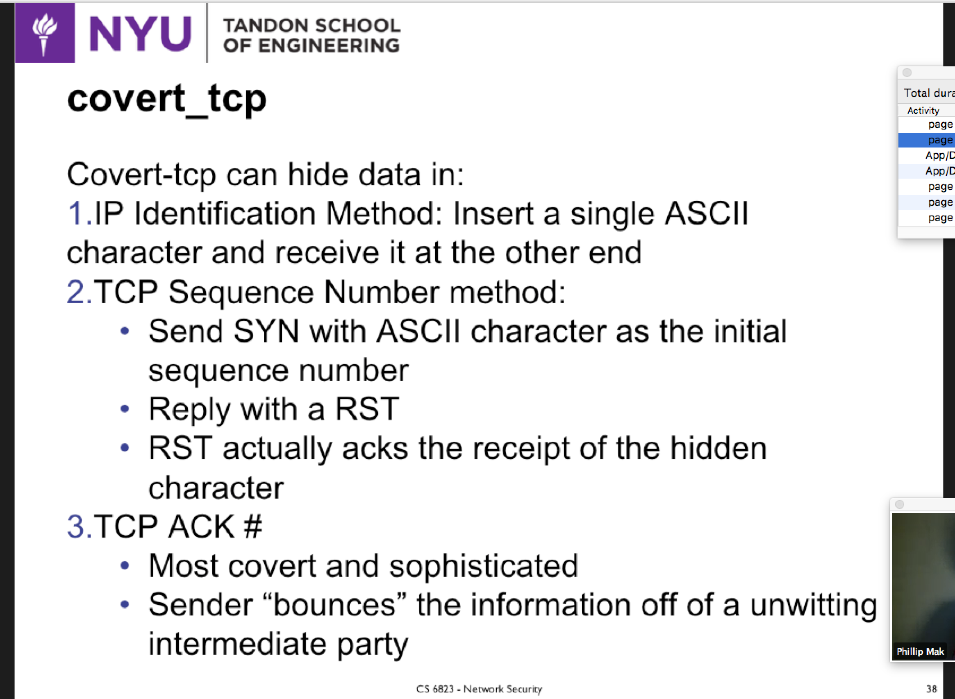

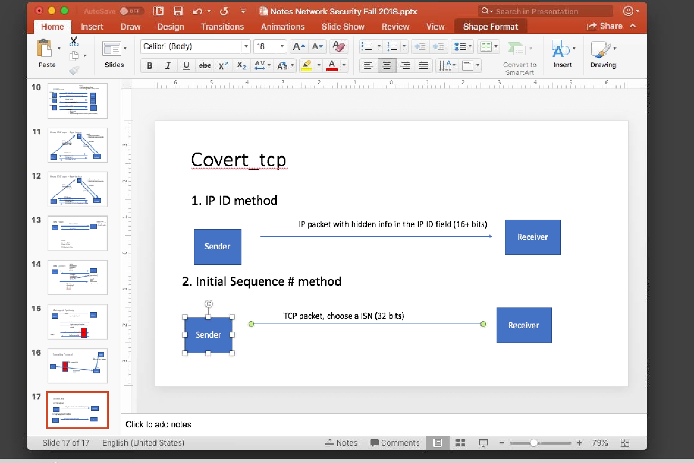

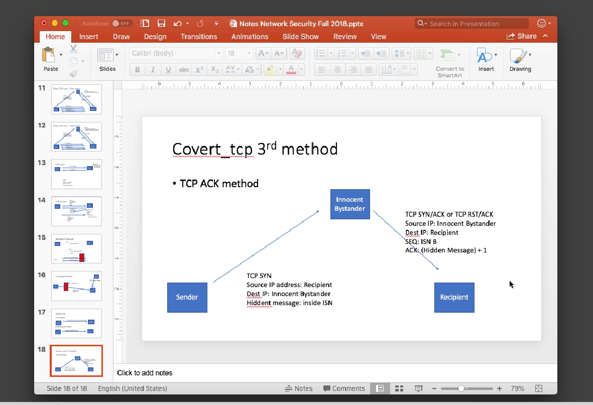

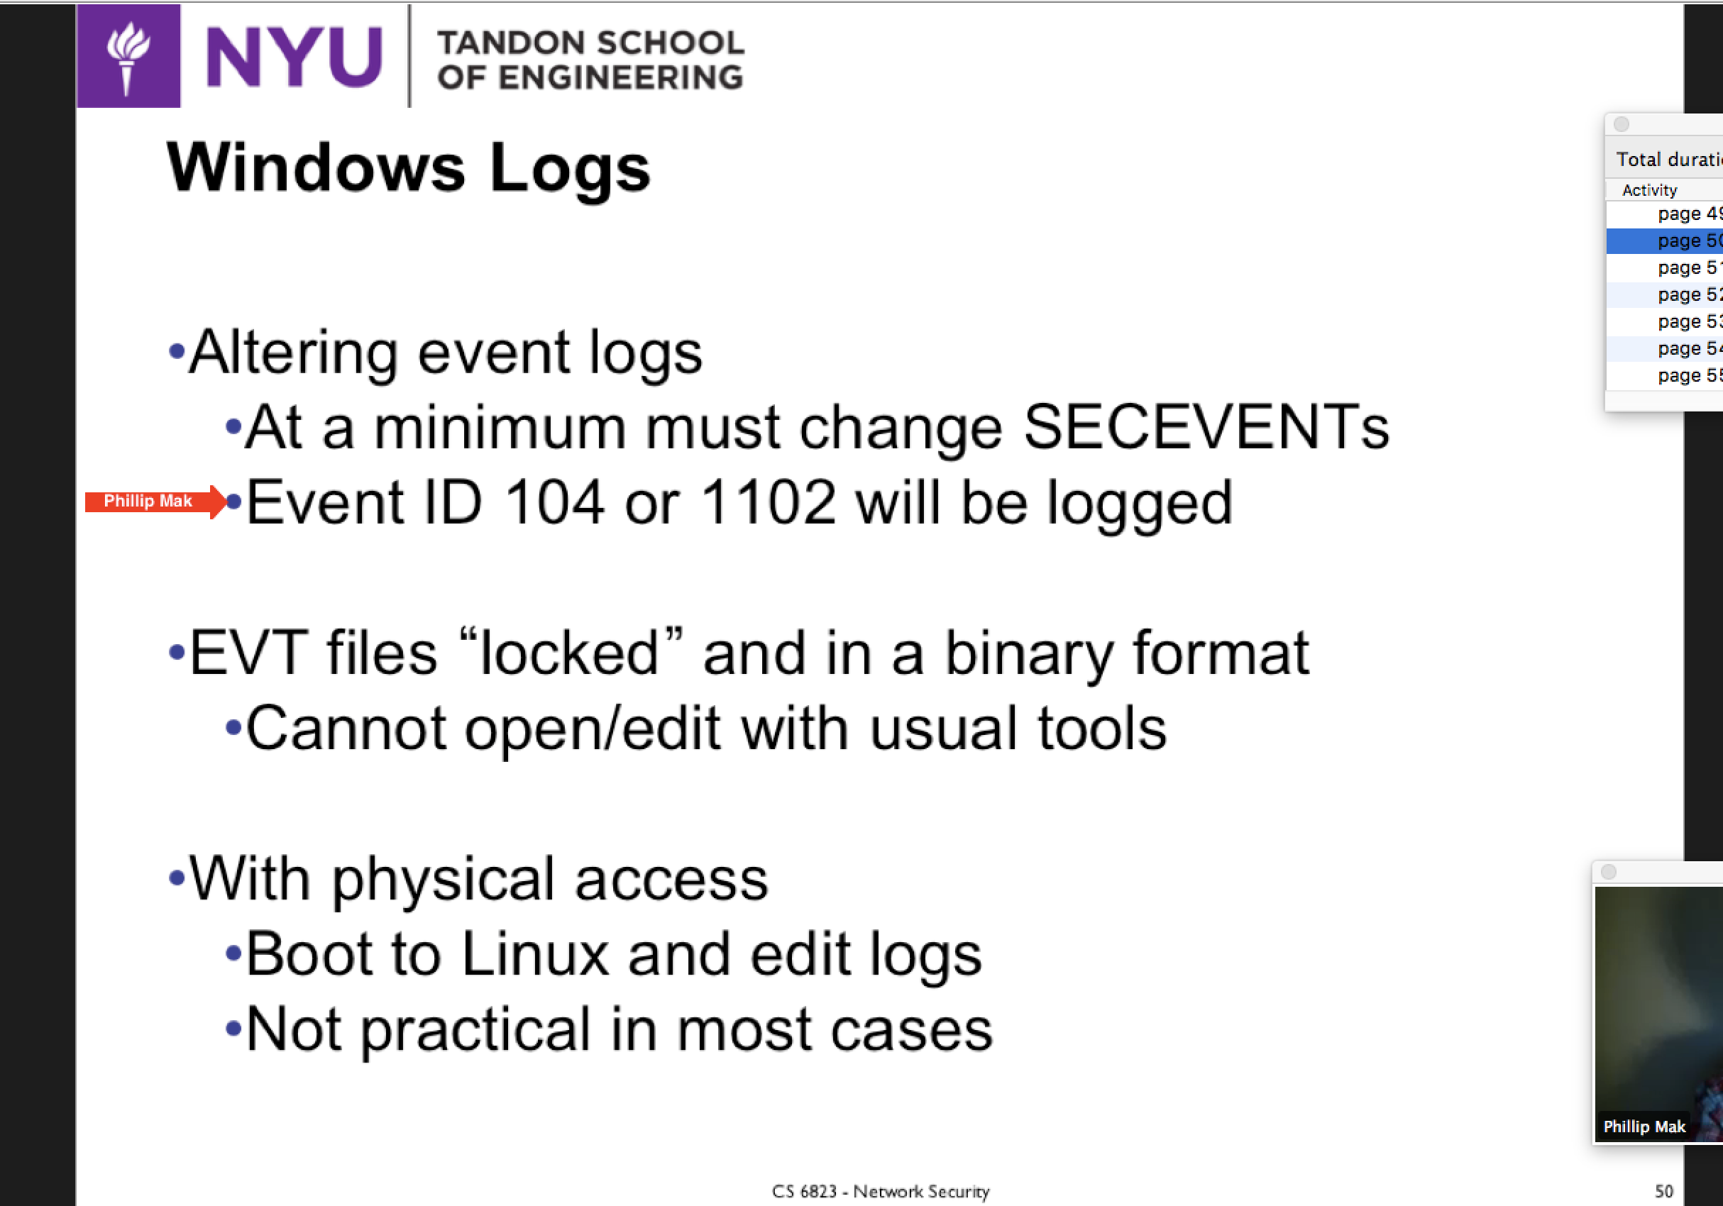

**CRYPTOGRAPHY**

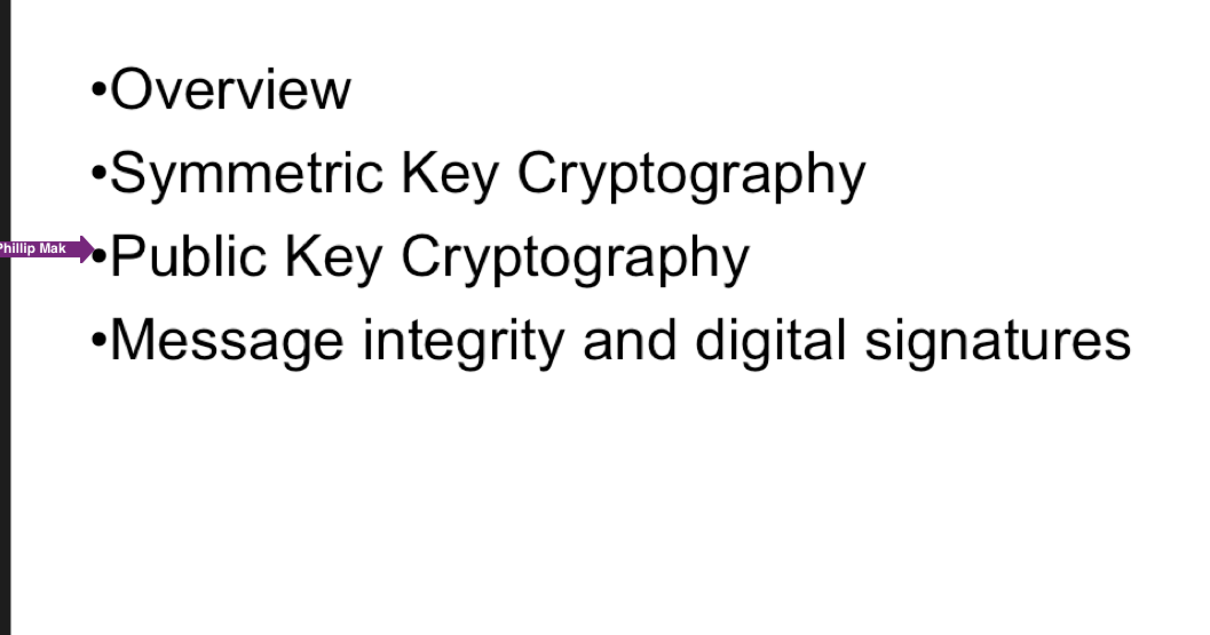

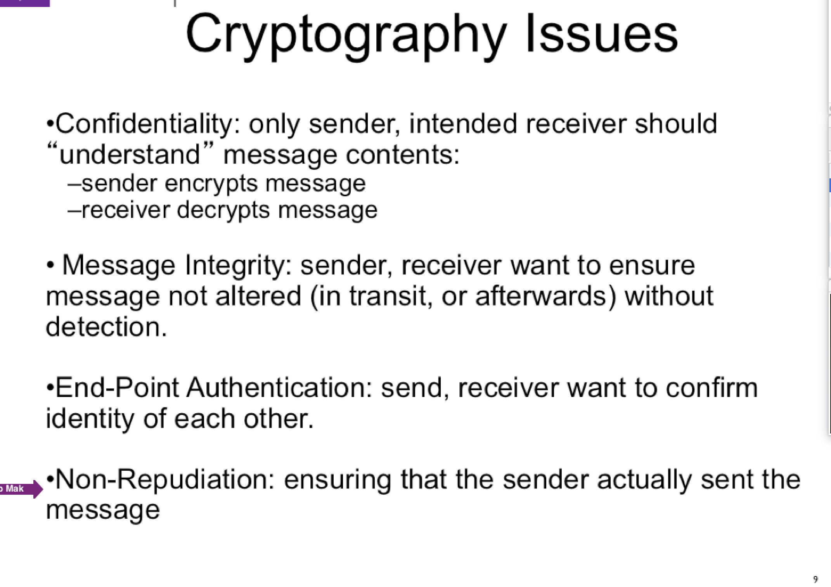

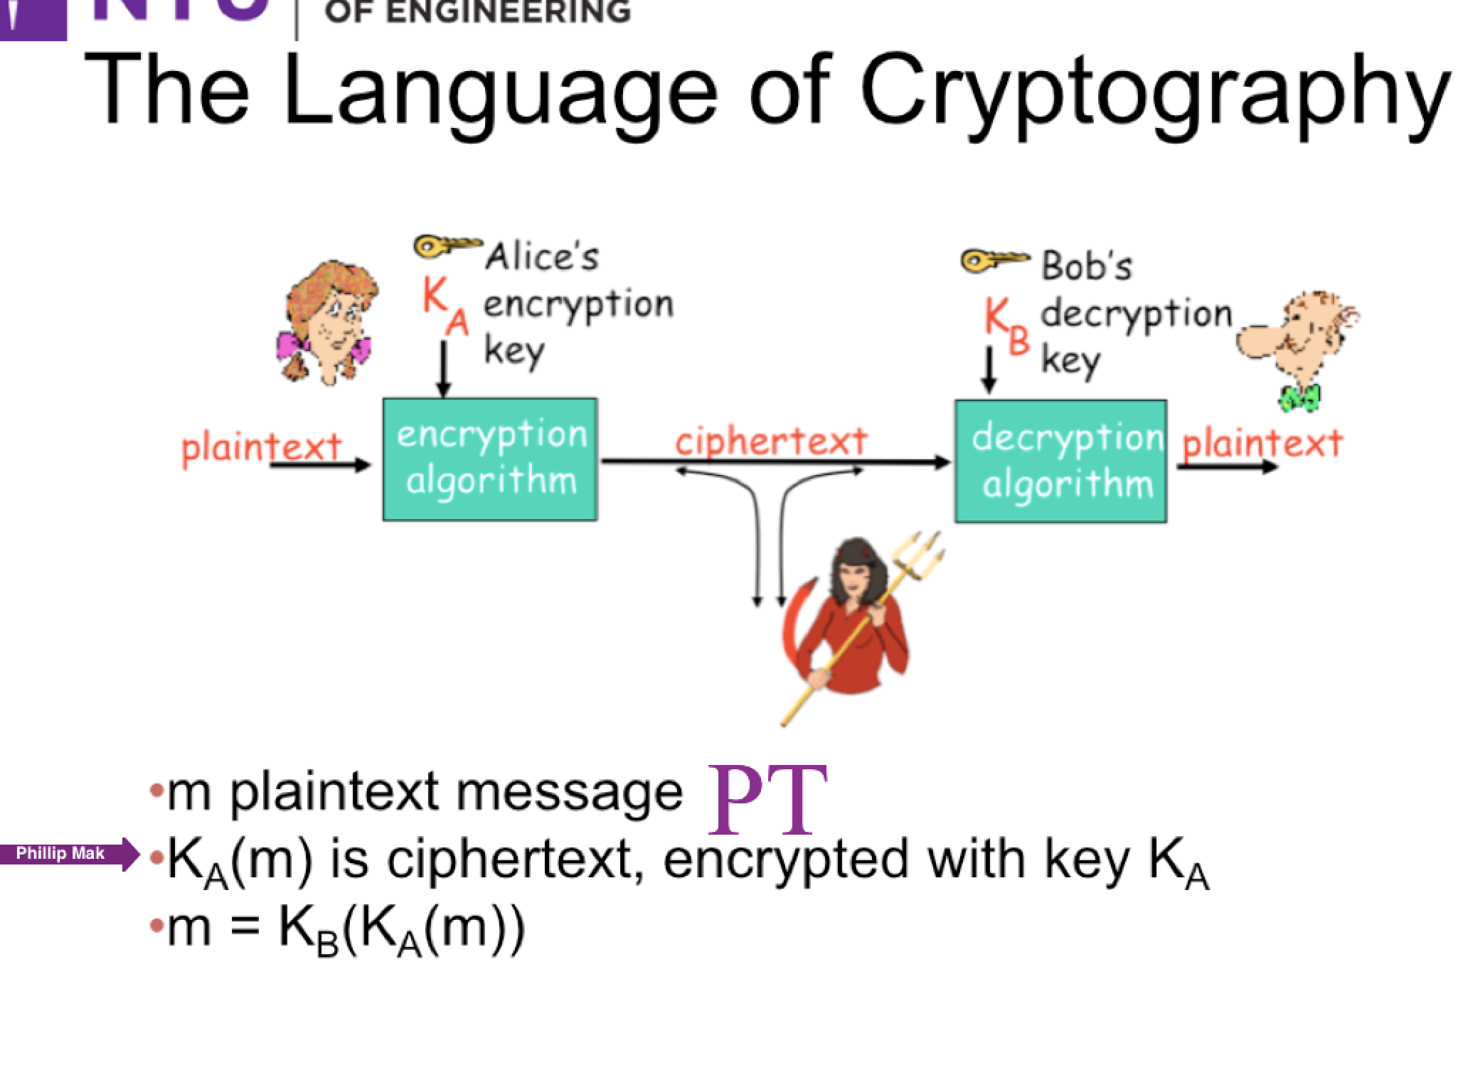

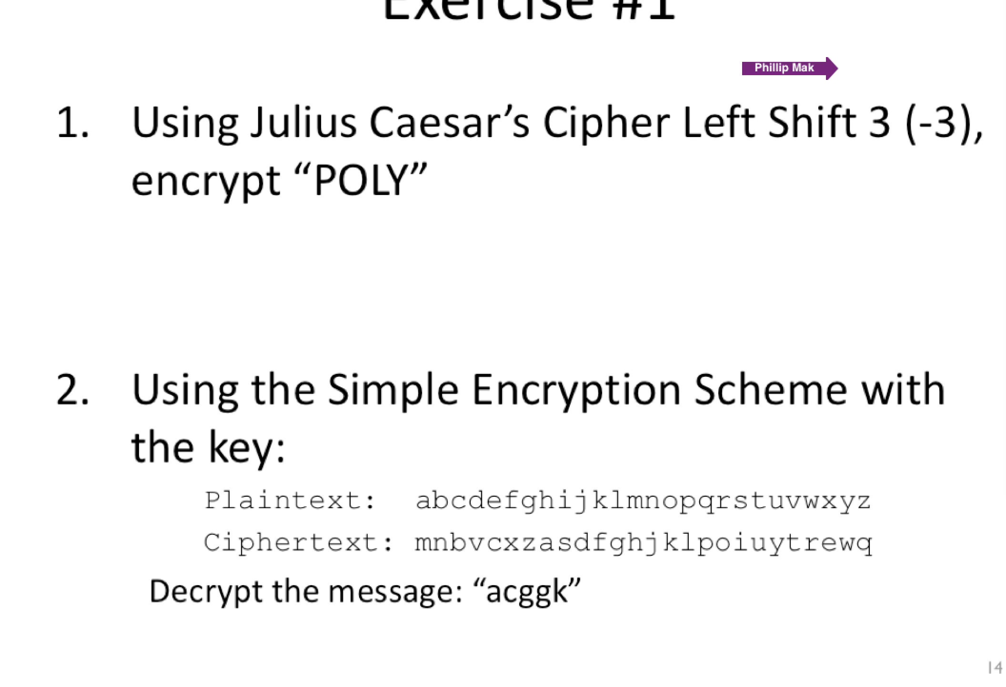

1. POLY = MLIV
2. ACGGK = HELLO

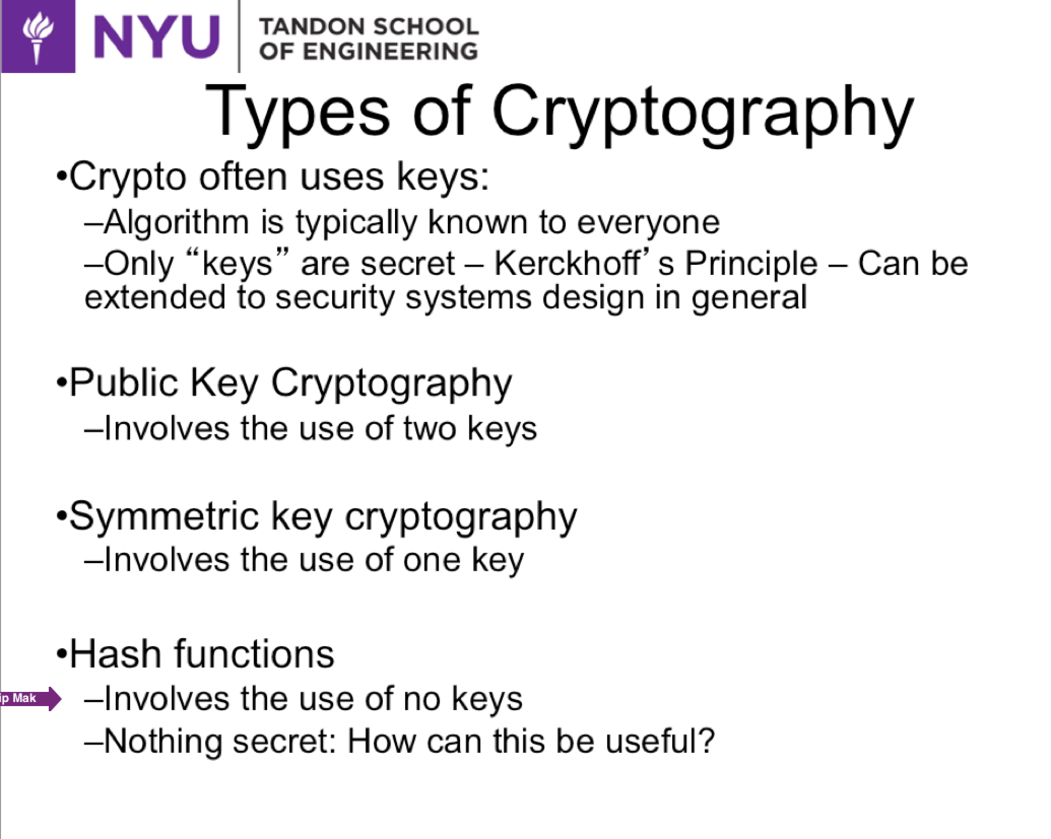

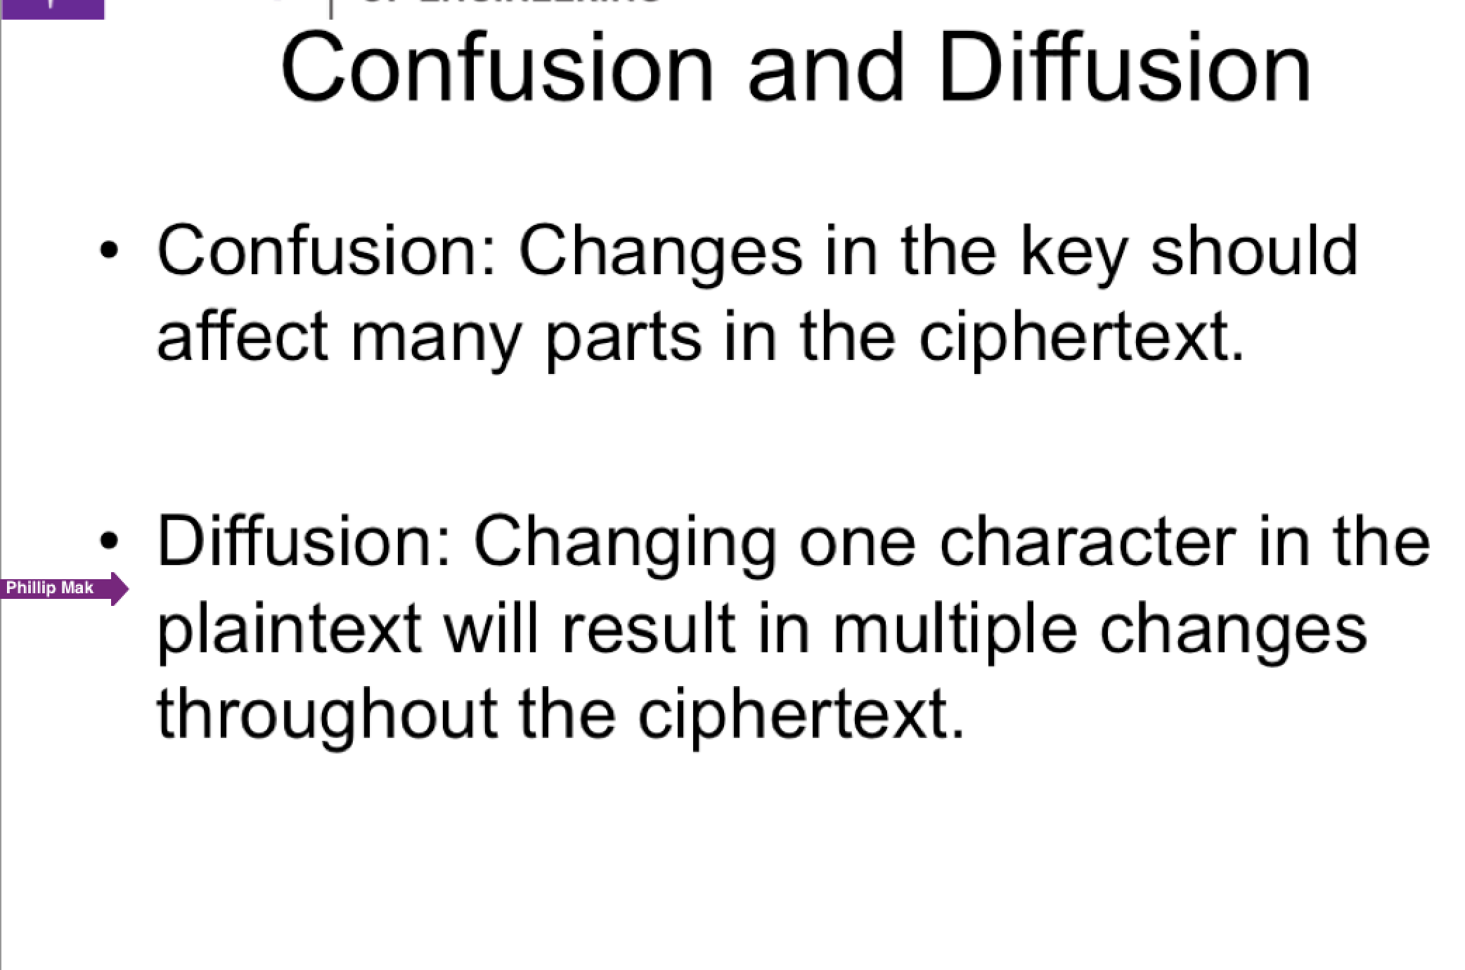

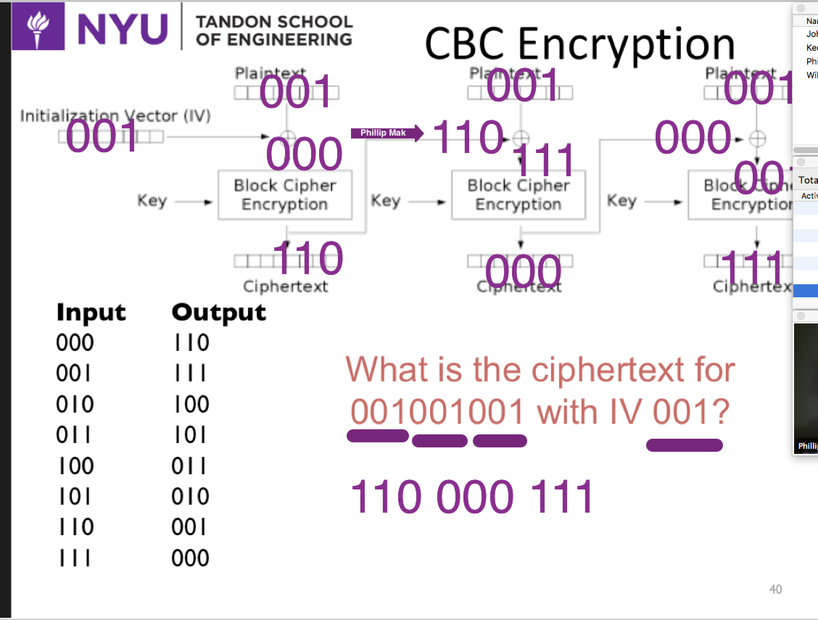

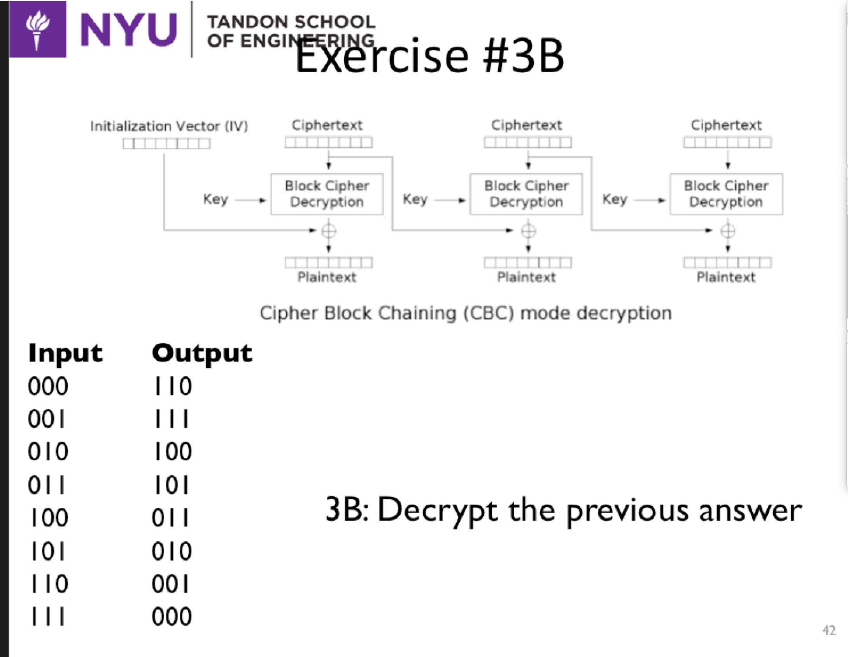

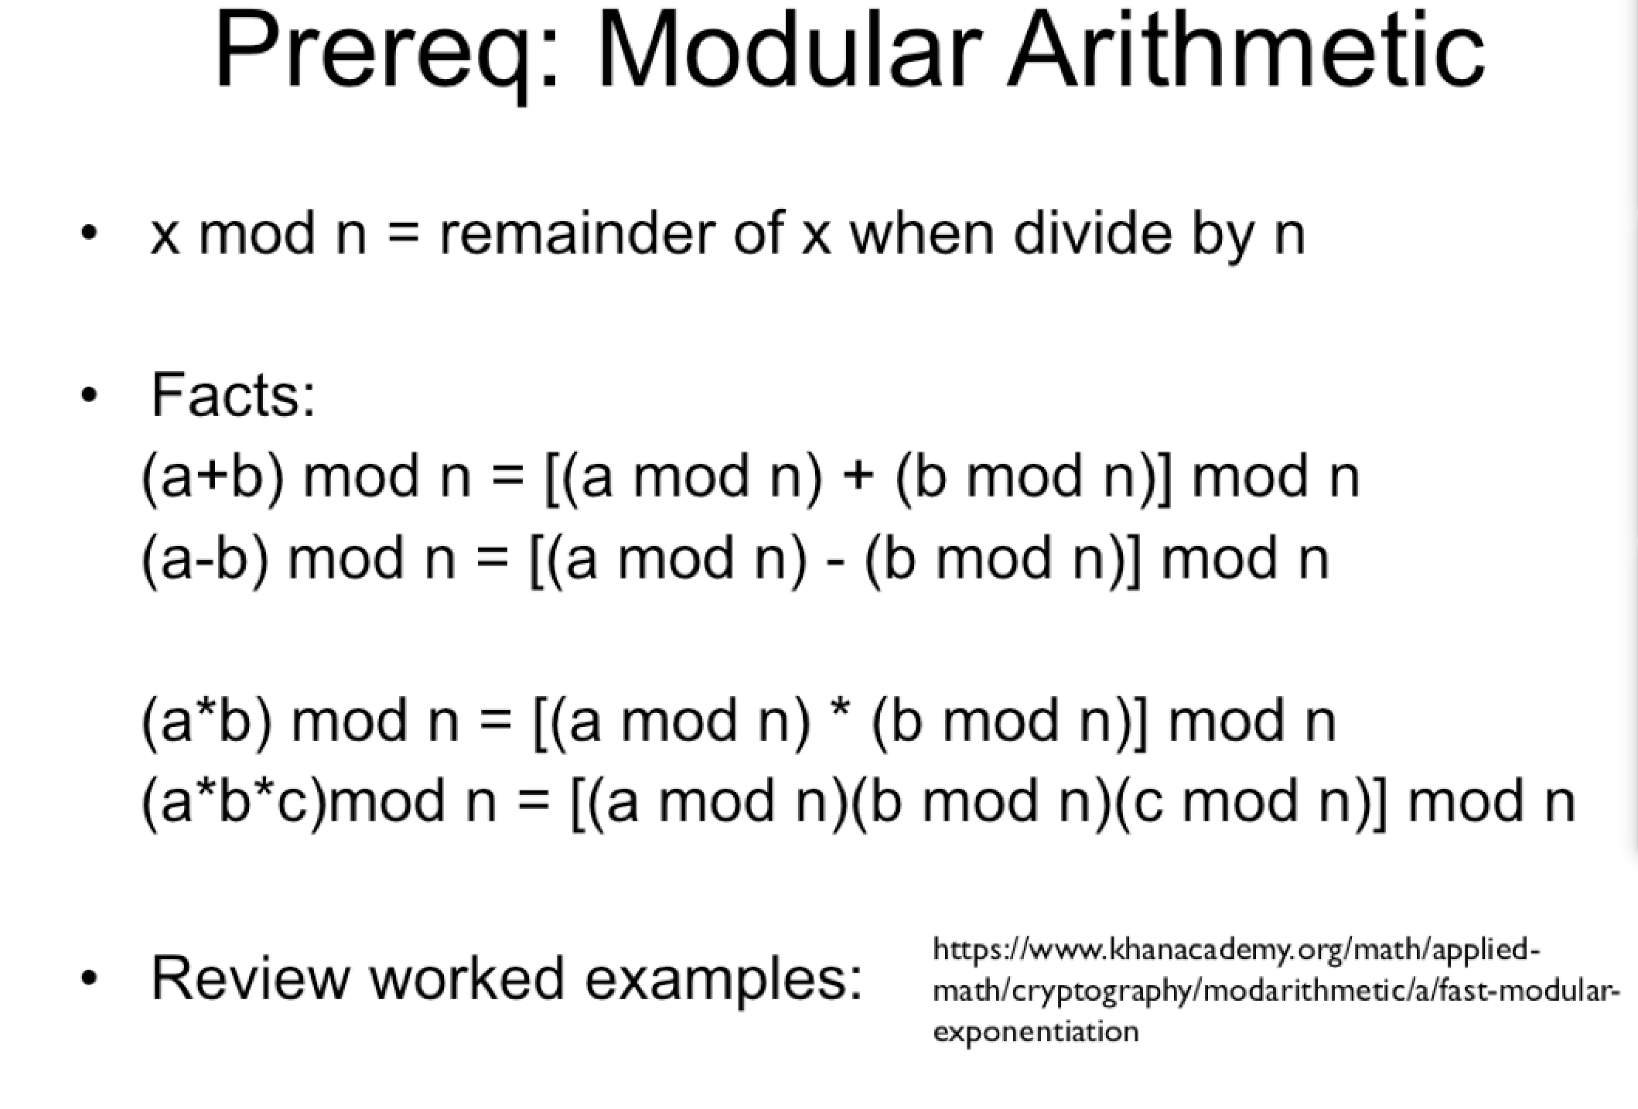

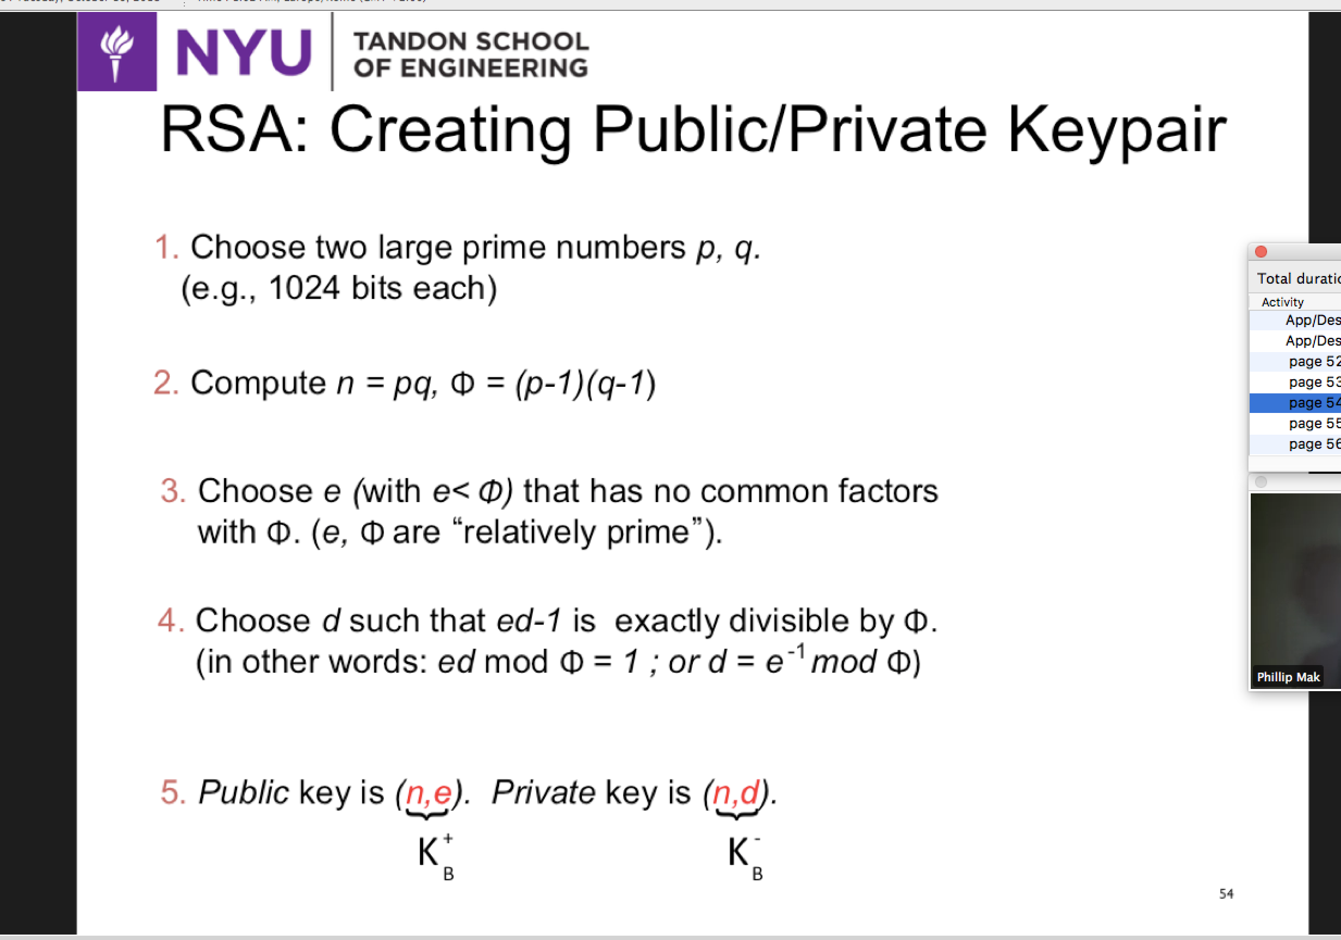

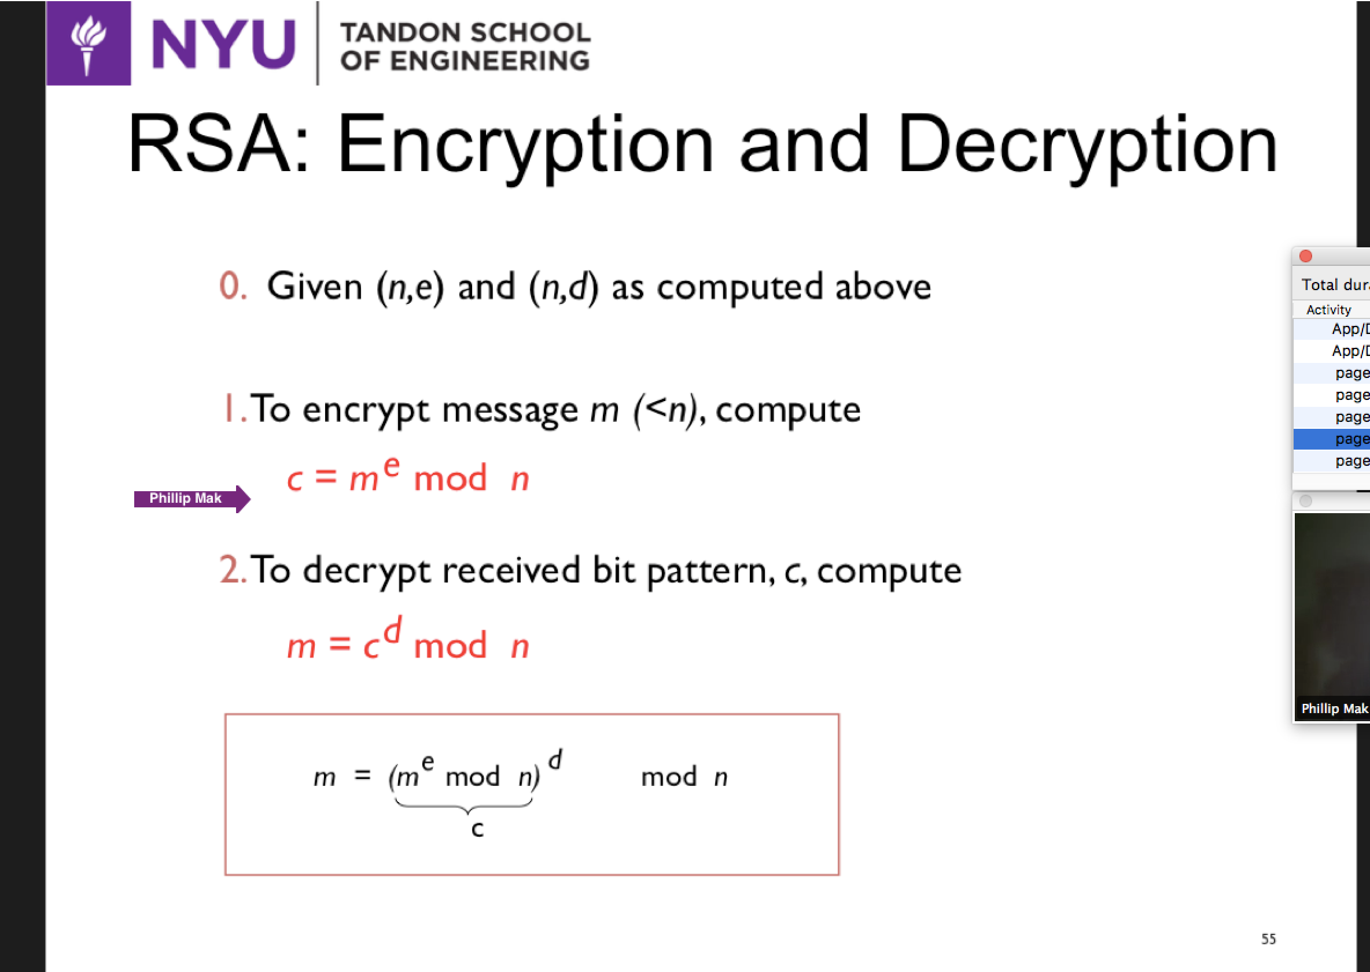



**I DON’T KNOW:**